

**CC4057NI\CC4058NI Introduction to Information System**

**60% Group Coursework**

**2024-25 Autumn**

|  |  |  |  |
| --- | --- | --- | --- |
| **Group Name:** | | | |
| **SN** | **Student Name** | **College ID** | **University ID** |
| **1** | **Rivesh Pandey** | **NP01CP4A240099** | **24046840** |
| **2** | **Rupesh Nepal** | **NP01CP4A240211** | **24046847** |
| **3** | **Salina Karki** | **NP01CP4A240292** | **24046951** |
| **4** | **Asim Bhusal** | **NP01CP4A240114** | **24046721** |
| **5** | **Suzal Lama** |  |  |

**Assignment Due Date: Saturday, February 1, 2025**

**Assignment Submission Date: Sunday, February 2, 2025**

**Word Count: 1456**

*I confirm that I understand my coursework needs to be submitted online via MySecondTeacher under the relevant module page before the deadline in order for my assignment to be accepted and marked. I am fully aware that late submissions will be treated as non-submission and a mark of zero will be awarded.*

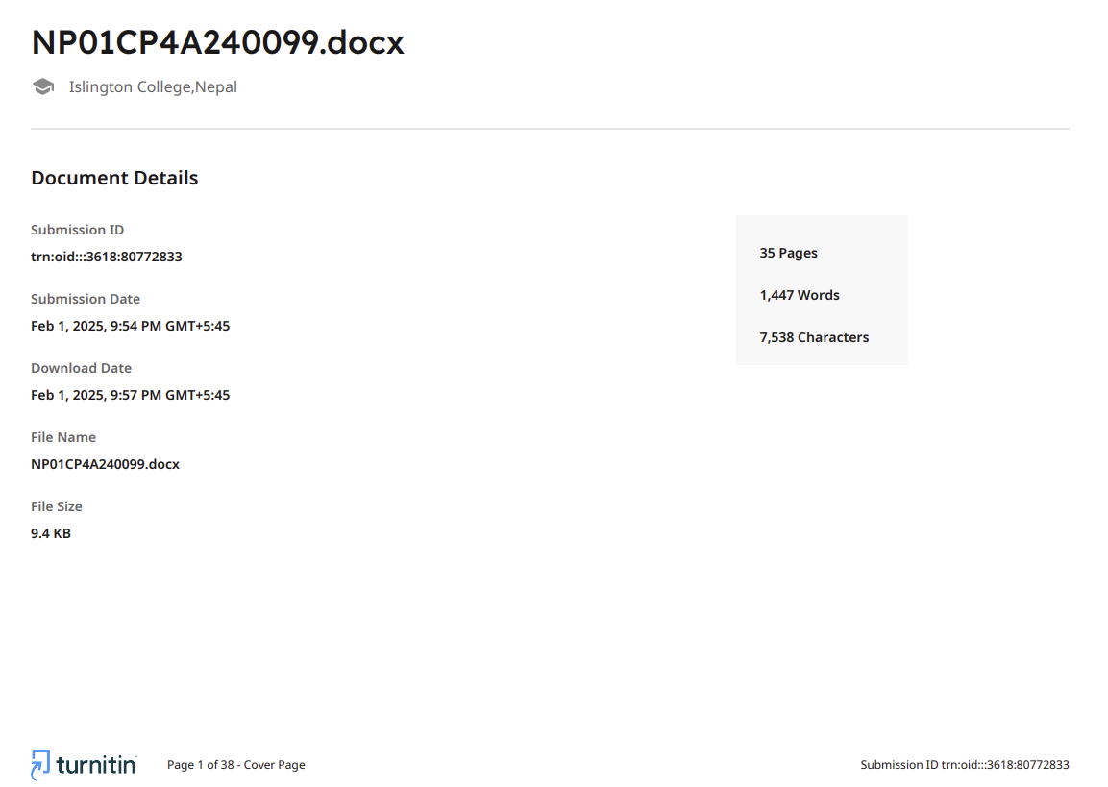

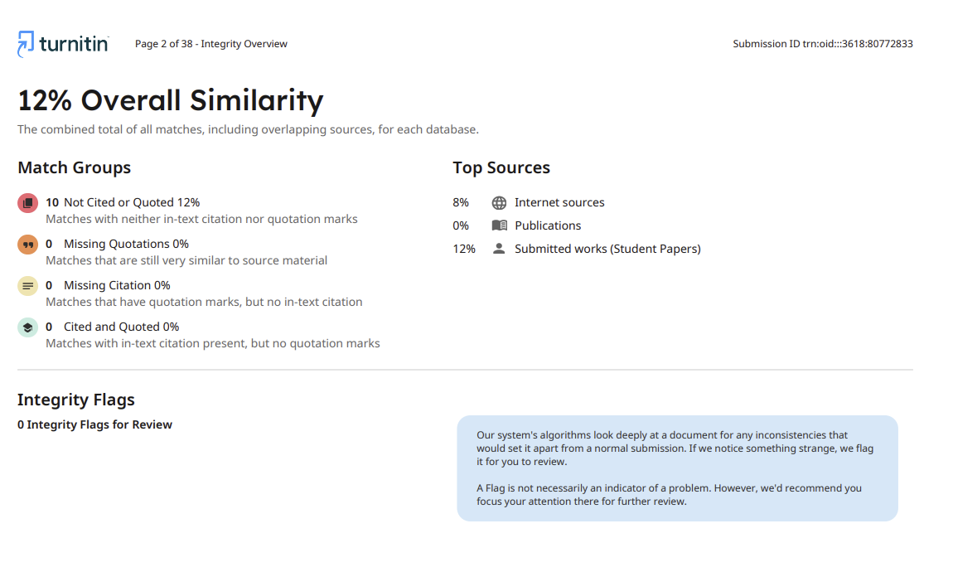

Table of Contents

1. Introduction 1

2. Discussion and Analysis 1

2.1. Visual Studio Code 2

2.2. Balsamiq Mock-up’s 2

2.3. HTML 3

2.4. CSS 4

2.5. JavaScript 4

3. Webpages and their wireframes 5

3.1. Homepage 5

3.2. Products 7

3.3. Blog 9

3.4. About Us 11

3.5. Research 13

3.6. Login 15

4. Test Cases 16

Test 4.1 Form Validation 16

Test 4.2 Hoover Effect 17

Test 4.3: Display message while opening website 18

Test 4.4: External links 19

Test 4.5: Internal Links 20

Test 4.6: Add to Cart 21

5. CONCLUSION 23

6. References 24

7. Appendix 25

7.1. Index.html 25

7.2. blog.html 40

7.3. product.html 51

7.4. research.html 66

7.6. loginpage.html 75

7.7. signuppage.html 79

7.8. index.css 84

7.9. java.js 88

Table of Figures

Figure 1 Visual Studio Code 2

Figure 2 Balsamiq Mock-ups 3

Figure 3 HTML 3

Figure 4 CSS 4

Figure 5 JavaScript 4

Figure 6 Homepage Web 5

Figure 7 Wireframe Homepage 6

Figure 8 Products Web 7

Figure 9 Wireframe Products 8

Figure 10 Blog Web 9

Figure 11 Wireframe Blog 10

Figure 12 About us Web 11

Figure 13 WireFrame About Us 12

Figure 14 Research Web 13

Figure 15 Wireframe Research 14

Figure 16 Login Web 15

Figure 17 Wireframe Login 15

Table of tables

Table 1 Form Validation 16

Table 2 Hoover Effect 17

Table 3 Display message while clicking the website 18

Table 4 External Links 19

Table 5 Internal Links 20

Table 6 Add to Cart 21

# Introduction

The first group assignment for the Introduction to Information Systems, our module leader, Mr Hrishav Tandukar, assigned us to create an e-commerce website for a business that sells different watches. There were some obstacles to overcome when creating this e-commerce website because all the members at group were new and unfamiliar with the idea of creating a complete website using HTML, CSS and JavaScript. However, we successfully completed the project in the end.

For this project, we are going to making an e-commerce website using other six different webpages. Firstly, the users are introduced to smart watches while they click the website in the index page, i.e. home page. Along with that they can purchase various smart watches according to their needs. They can also use customer care and contact us through about us section. Users can get information about the company whose watches are listed at the e-commerce website in the blog section.

# Discussion and Analysis

In order to have a clear knowledge of what should and shouldn’t be done for your website, we must create a prototype before we can create a properly operating website. Balsamiq is used to create a wireframe for a prototype. A wireframe is a dimensional representation of a page’s interface that focuses on content priority, space allocation, accessible features and desired actions. Because of these factors, wireframes usually don’t have any images, colour or styling. Additionally, a text editor is utilized for coding while creating a website. The text editor we will be utilizing is Visual Studio Code. The website is programmed using HTML, CSS and JavaScript.

## Visual Studio Code

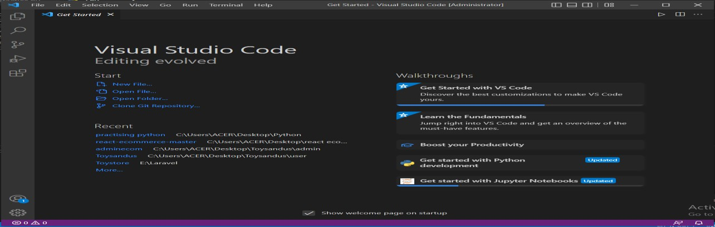With a focus on code editing for a range of development contexts, such as online, mobile, and cloud development, Visual Studio Code is an open source and cross-platform programming tool. Write and debug code fast and effectively with Visual Studio Code on every platform, device, programming language, and operating system of your choosing (Del Sole, 2019).

Figure 1 Visual Studio Code

## Balsamiq Mock-up’s

Balsamiq Mock-up’s is a graphical user interface mock-ups builder application which allows users to arrange pre-built widgets using a drag and drop editor. It comprises of a few basic components which are used while creating the mock-up (Mohite, 2014).

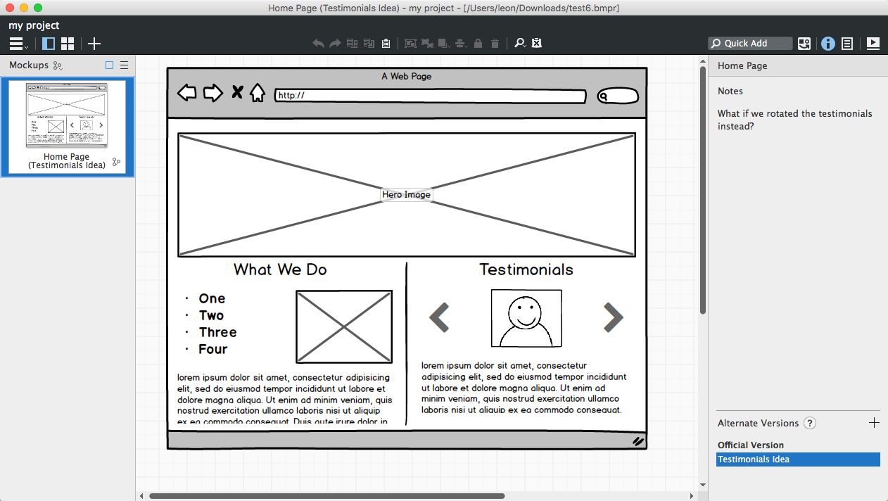

Figure 2 Balsamiq Mock-ups

## HTML

The coding that organizes a web page and its contents is called HTML (Hyper Text Markup Language). Content might be organized, for instance, using data tables and graphics, a list of bulleted points, or a series of paragraphs (Castro, 2003).



Figure 3 HTML

## CSS

With Cascading Style Sheets (CSS), you may define the presentation and visual style of your online application. You can distinguish between style and structure using CSS. This implies that you are examining less code while interacting with your page. Keeping design distinct from content and organization also makes things easier to manage. A collection of programmable rules called Cascading Style Sheets specify how the material on your web pages is displayed (Grant, 2024).

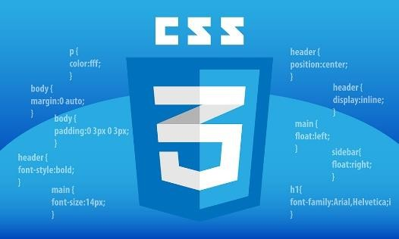

Figure 4 CSS

## JavaScript

JavaScript is the programming language of the Web. JavaScript is a high-level, dynamic, untyped interpreted programming language that is well-suited to object-oriented and functional programming styles. Java Script derives its syntax from Java (Flanagan, 2011).



Figure 5 JavaScript

# Webpages and their wireframes

Wireframes are simple back and white layouts that outline the exact size and placement of your website’s page elements, site features, conversion areas, and navigation.

## Homepage

Any website’s homepage is its default or homepage. To offer the consumer a clear idea of what to expect from the e-commerce site, the homepage of this website provides descriptions of the different latest smartwatches.

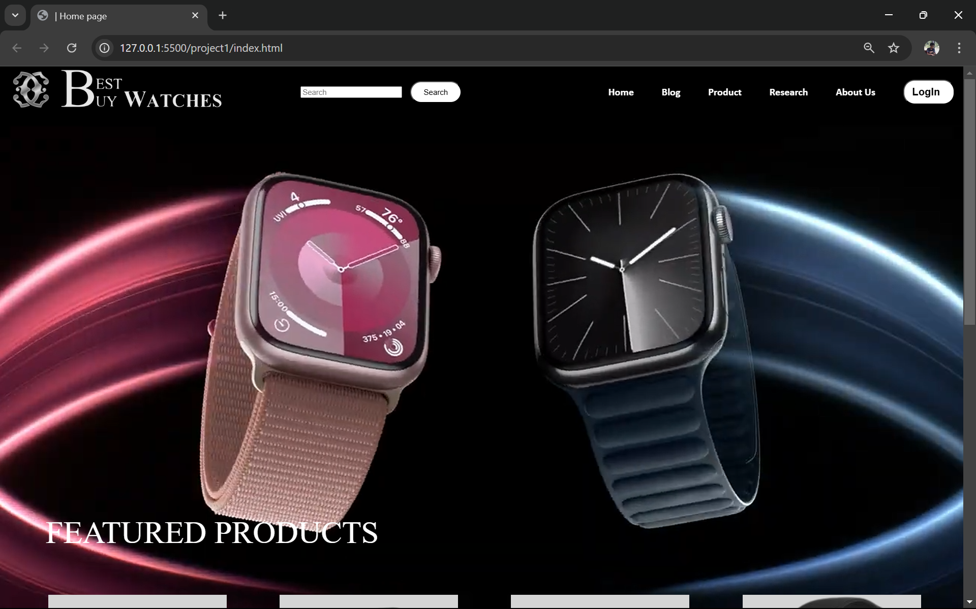

Figure 6 Homepage Web

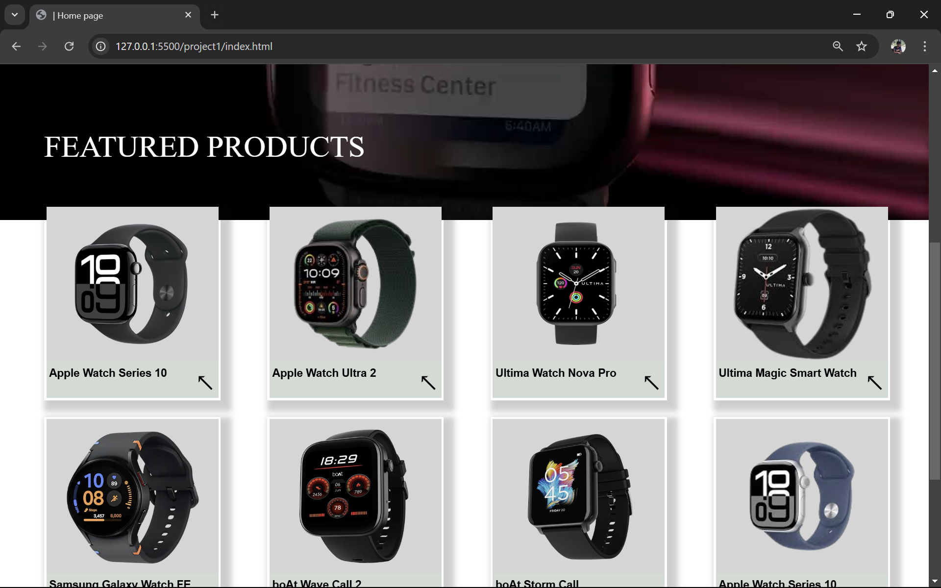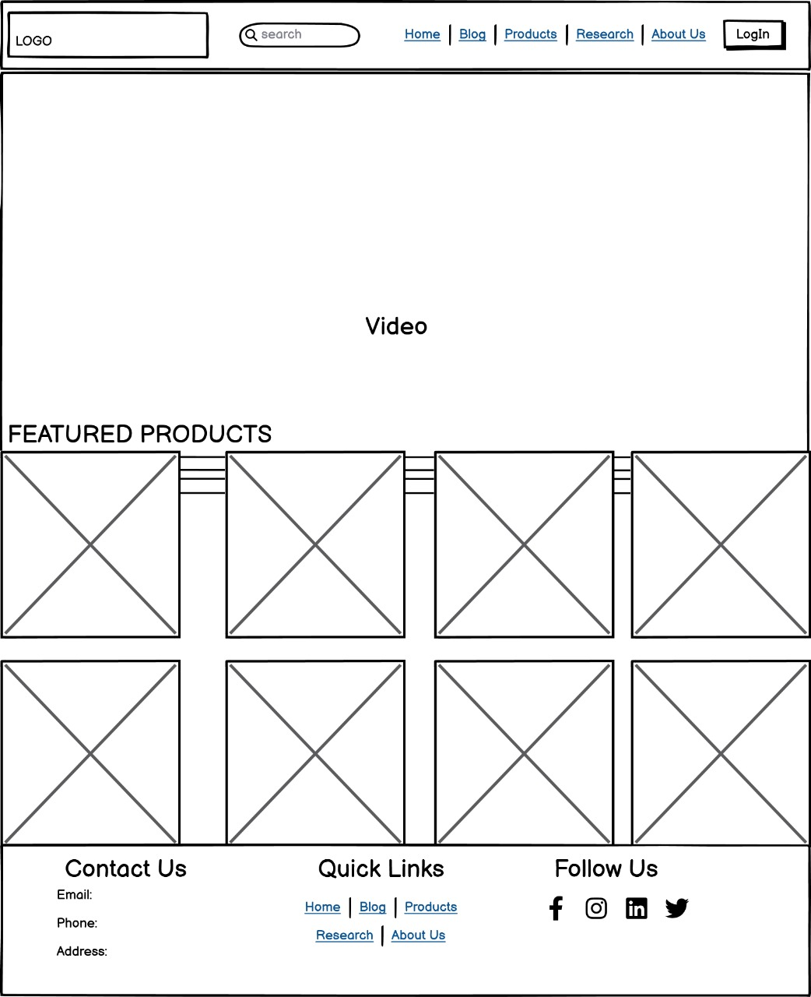

Figure 7 Wireframe Homepage

## Products

We may view a variety of items that are available for purchase on the internet by visiting the product page. After browsing a variety of smartwatches, the customer can click “Explore” button to complete the order.

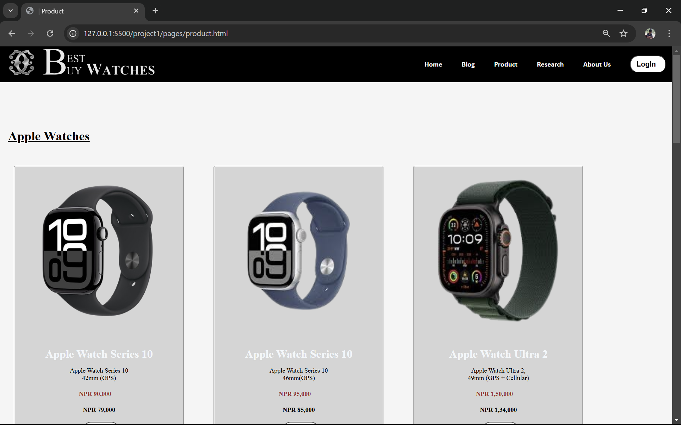 We

Figure 8 Products Web

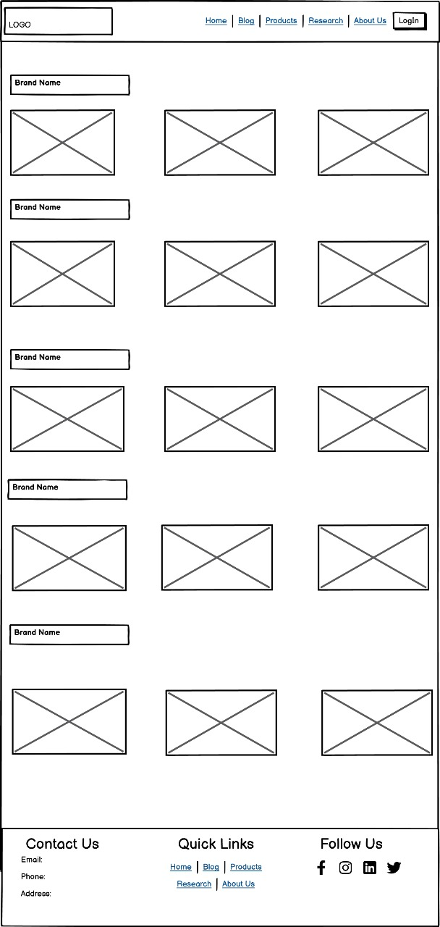

Figure 9 Wireframe Products

## Blog

The blog section provides various information and updates regarding the technology and its evolution, boost of sales, rise of smartwatches and some information regarding the company whose items have been listed.

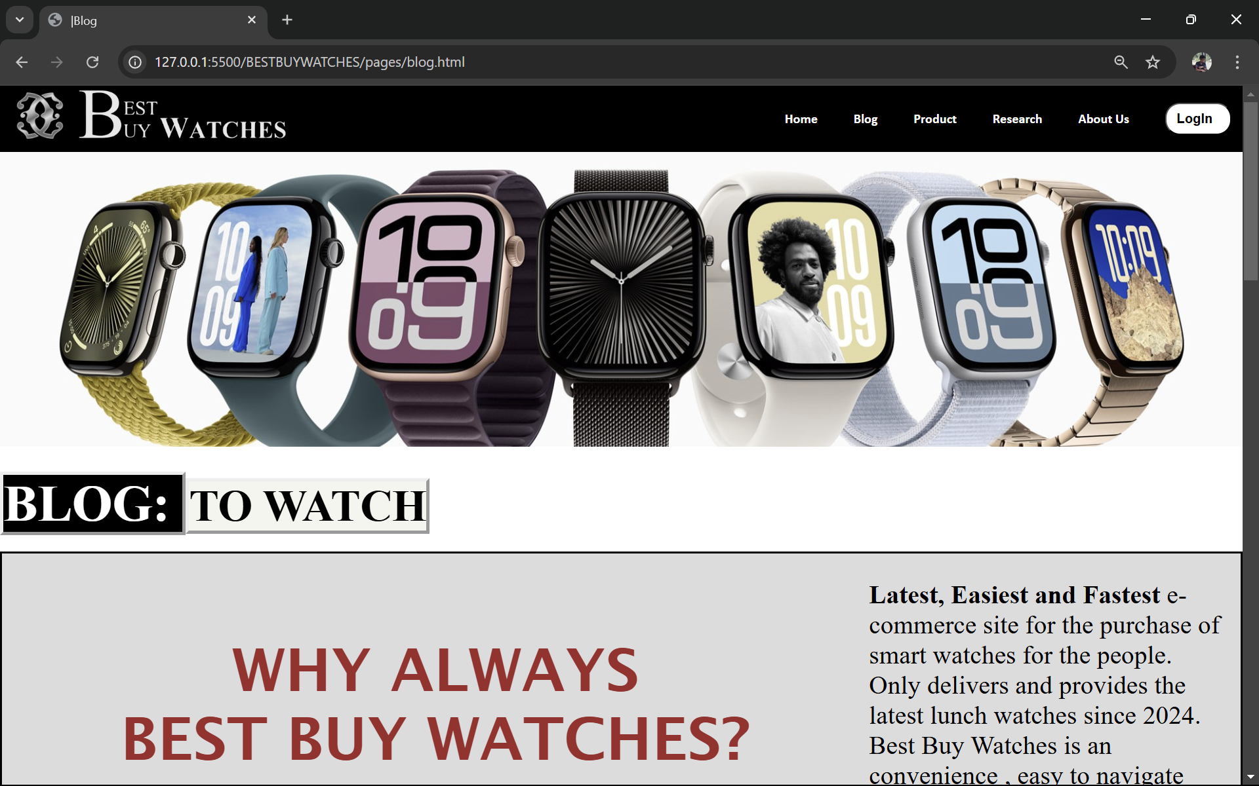

Figure 10 Blog Web

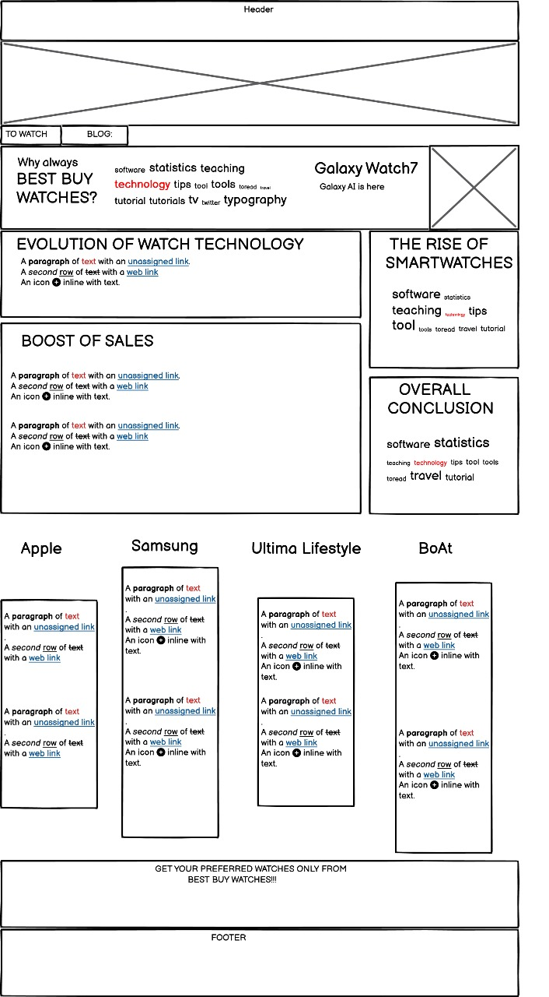

Figure 11 Wireframe Blog

## About Us

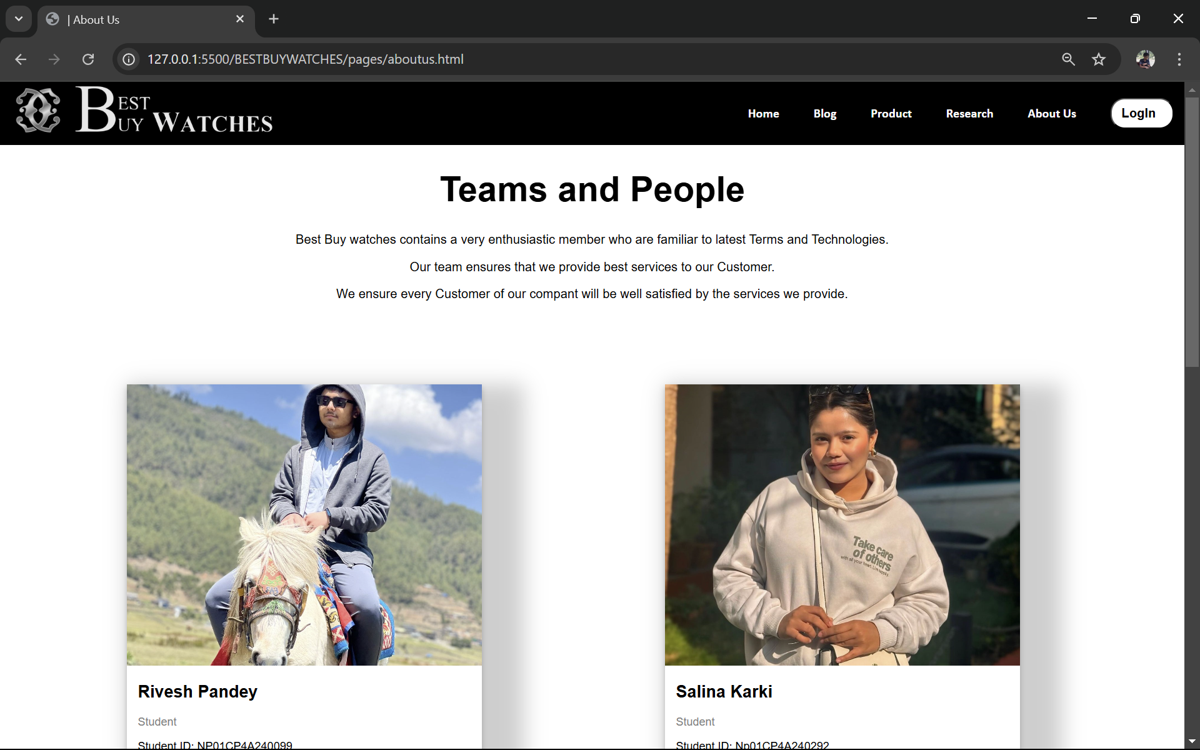In the about us page, the details of all the people who worked to make the project is listed and a feedback form is also provided to the user if they have any questions or any kind of feedback that is to be given to the developers of the website.

Figure 12 About us Web

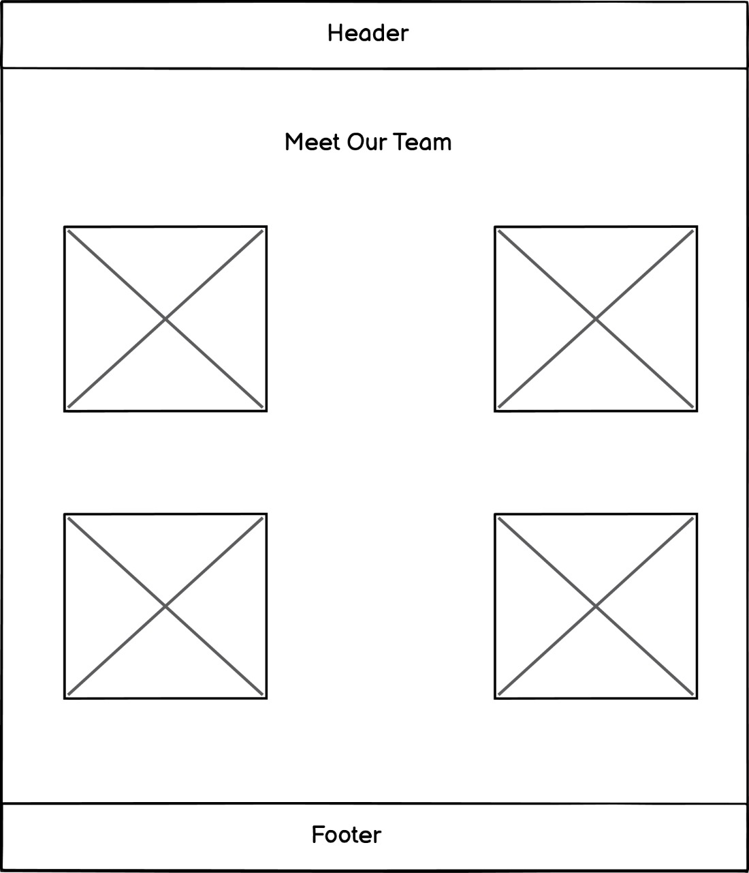

Figure 13 WireFrame About Us

## Research

In the research section, we provide all the information on what we researched and referenced while making the website.

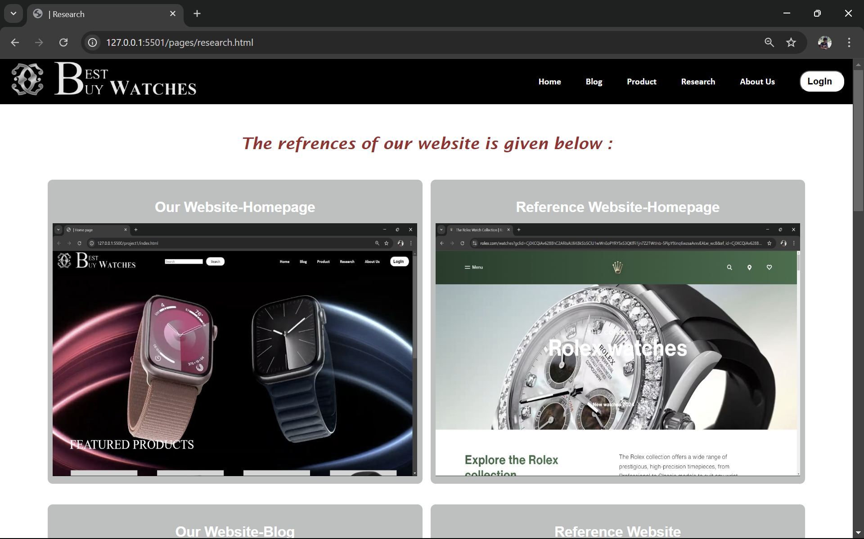

Figure 14 Research Web

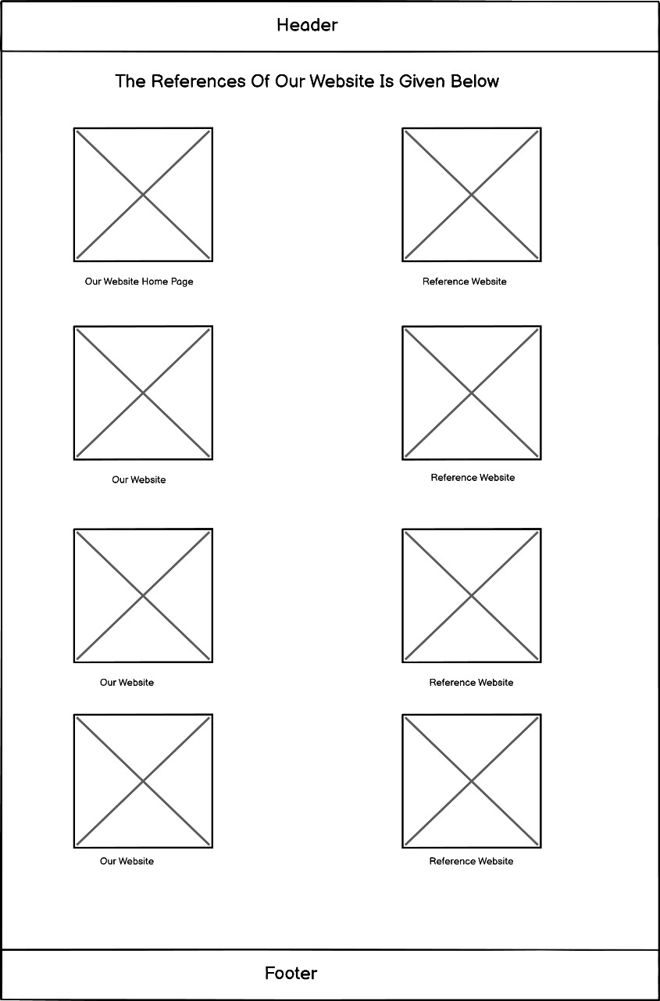

Figure 15 Wireframe Research

## Login

In the login page, users can login their existing account or open a new account if they are new to the webpage for further purchase of listed items on the website.

Figure 16 Login Web

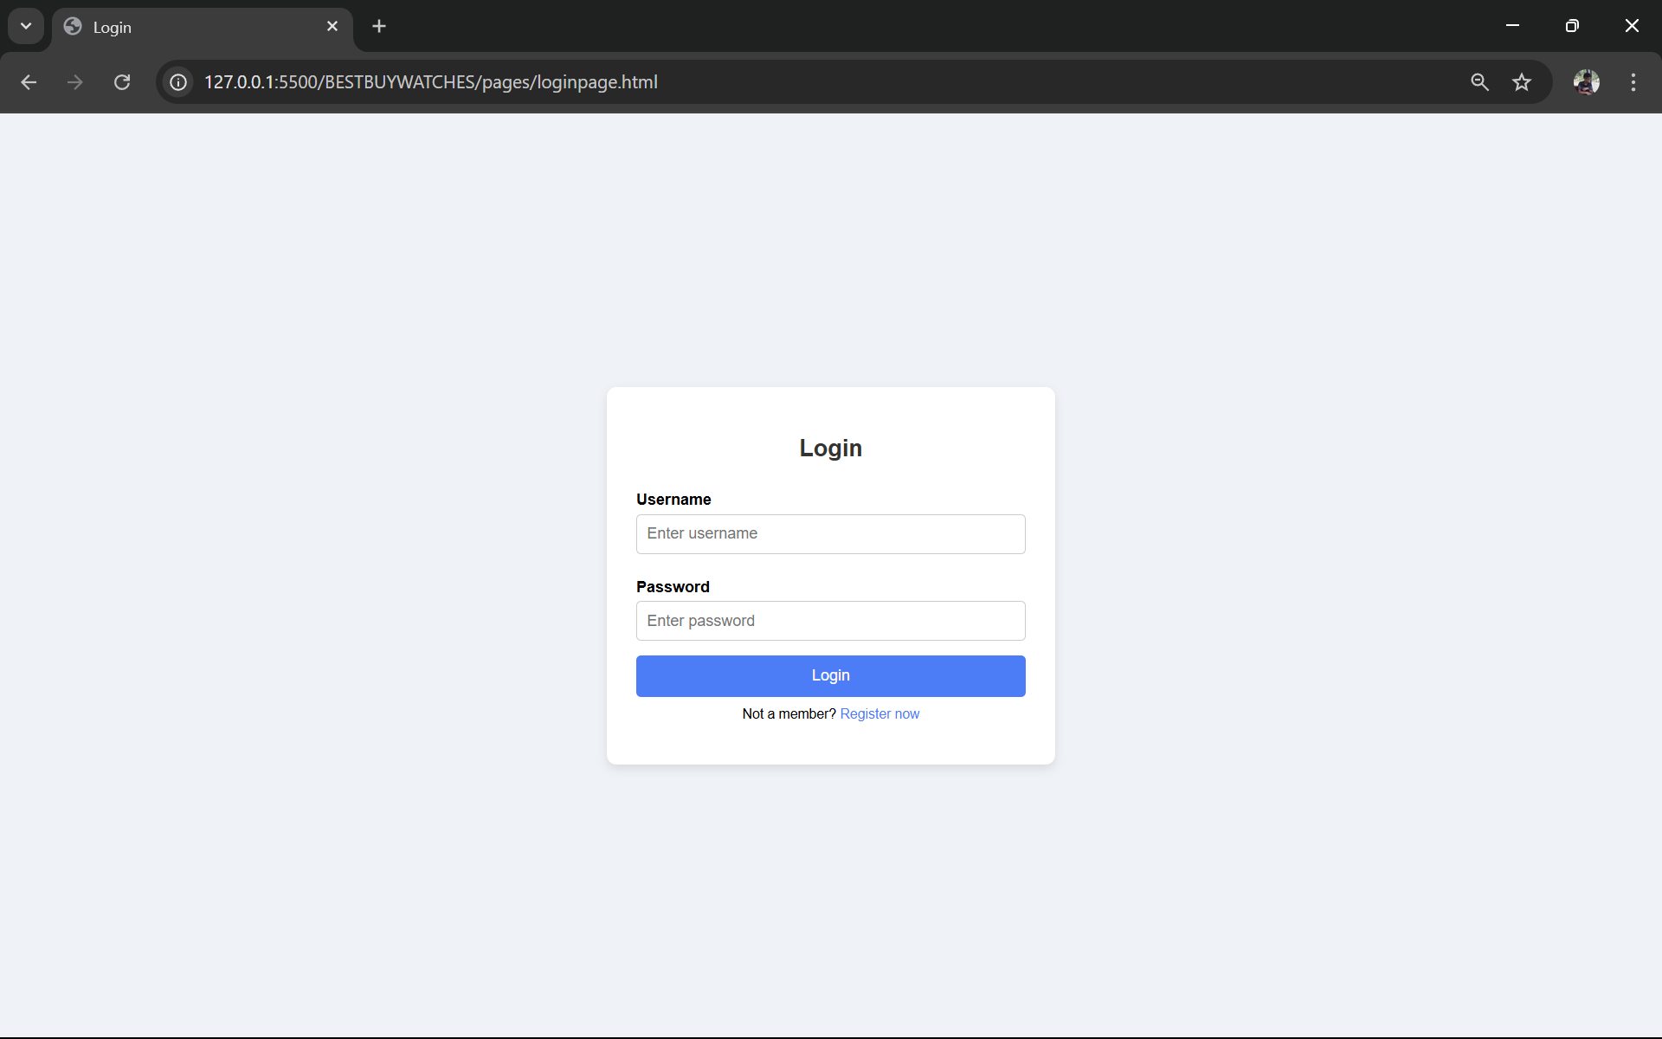

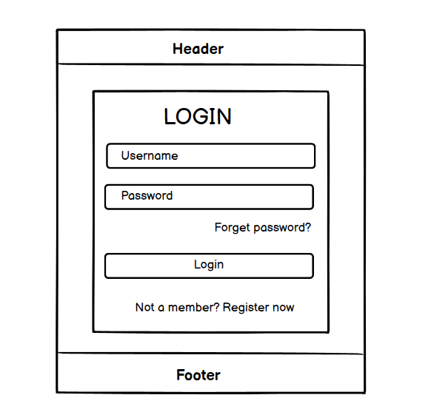

Figure 17 Wireframe Login

# Test Cases

The process of testing a website to see if it works is called testing. A web developer must check that pictures are shown correctly and that HTML elements are functioning correctly before launching a website. In addition, I’m going to make sure my website is still operational. We test the highlighted and important elements in the embraced website.

|  |  |
| --- | --- |
| Objective | To check whether the form is filled completely or not. |
| Action | Both fully and partially completing the form. |
| Expected Result | If the form is filled completely a pop-up appears saying “Successfully logged in”  If the from is not filled completely a pop-up appears saying “Please  completely fill the form”. |
| Actual Test | The correct pop-up appeared. |
| Result | The test was successful. |

## Test 4.1 Form Validation

Table 1 Form Validation

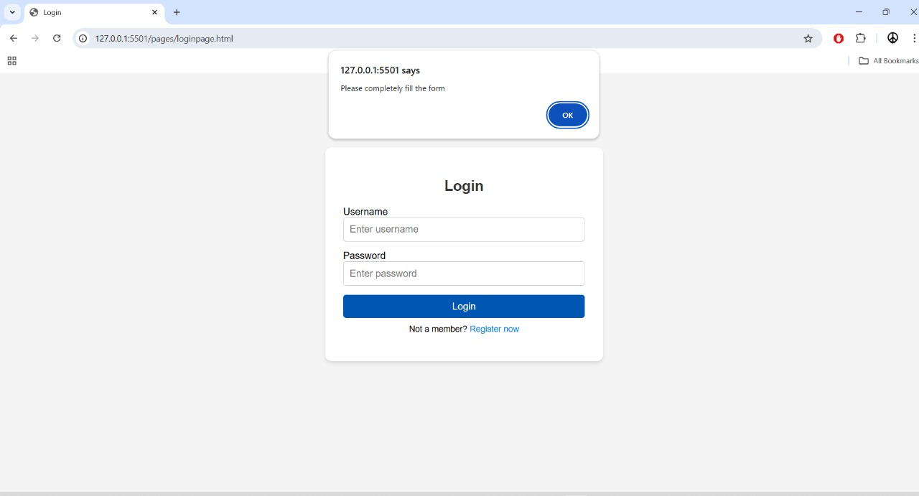

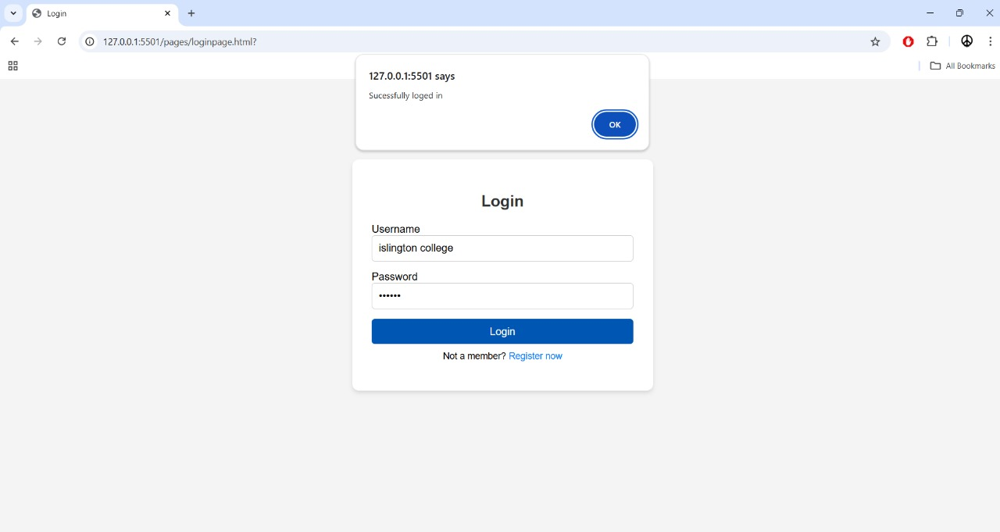

## Test 4.2 Hoover Effect

|  |  |
| --- | --- |
| Objective | To check whether the hover effect is working or not. |
| Action | The hover effect should change according to the cursor moved. |
| Expected Result | When clicked at the one of the options of navbar it should turn orange. |
| Actual Test | Yes, the hover effect worked and turned orange. |
| Result | The test was successful. |

Table 2 Hoover Effect



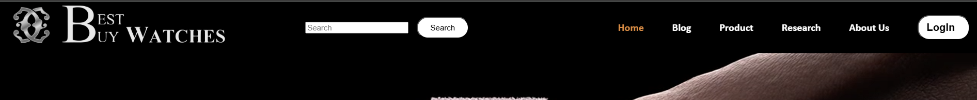





## Test 4.3: Display message while opening website

|  |  |
| --- | --- |
| Objective | To check if the message is displayed after opening the Homepage of the website. |
| Action | Click the website link |
| Expected Result | The Message “WELCOME TO BEST BUY WATCHES!!”  Should be displayed. |
| Actual Test | Opened the link. |
| Result | The test was successful. |

Table 3 Display message while clicking the website

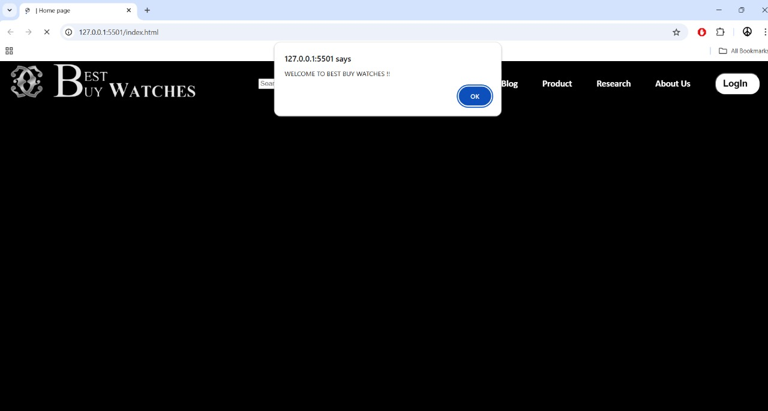

## Test 4.4: External links

Table 4 External Links

|  |  |
| --- | --- |
| Objective | To switch to another webpage using external links. |
| Action | Click the More Information in about us page to view the portfolio. |
| Expected Result | It will redirect to the respective profiles. |
| Actual Test | Opened the page. |
| Result | The test was successful. |

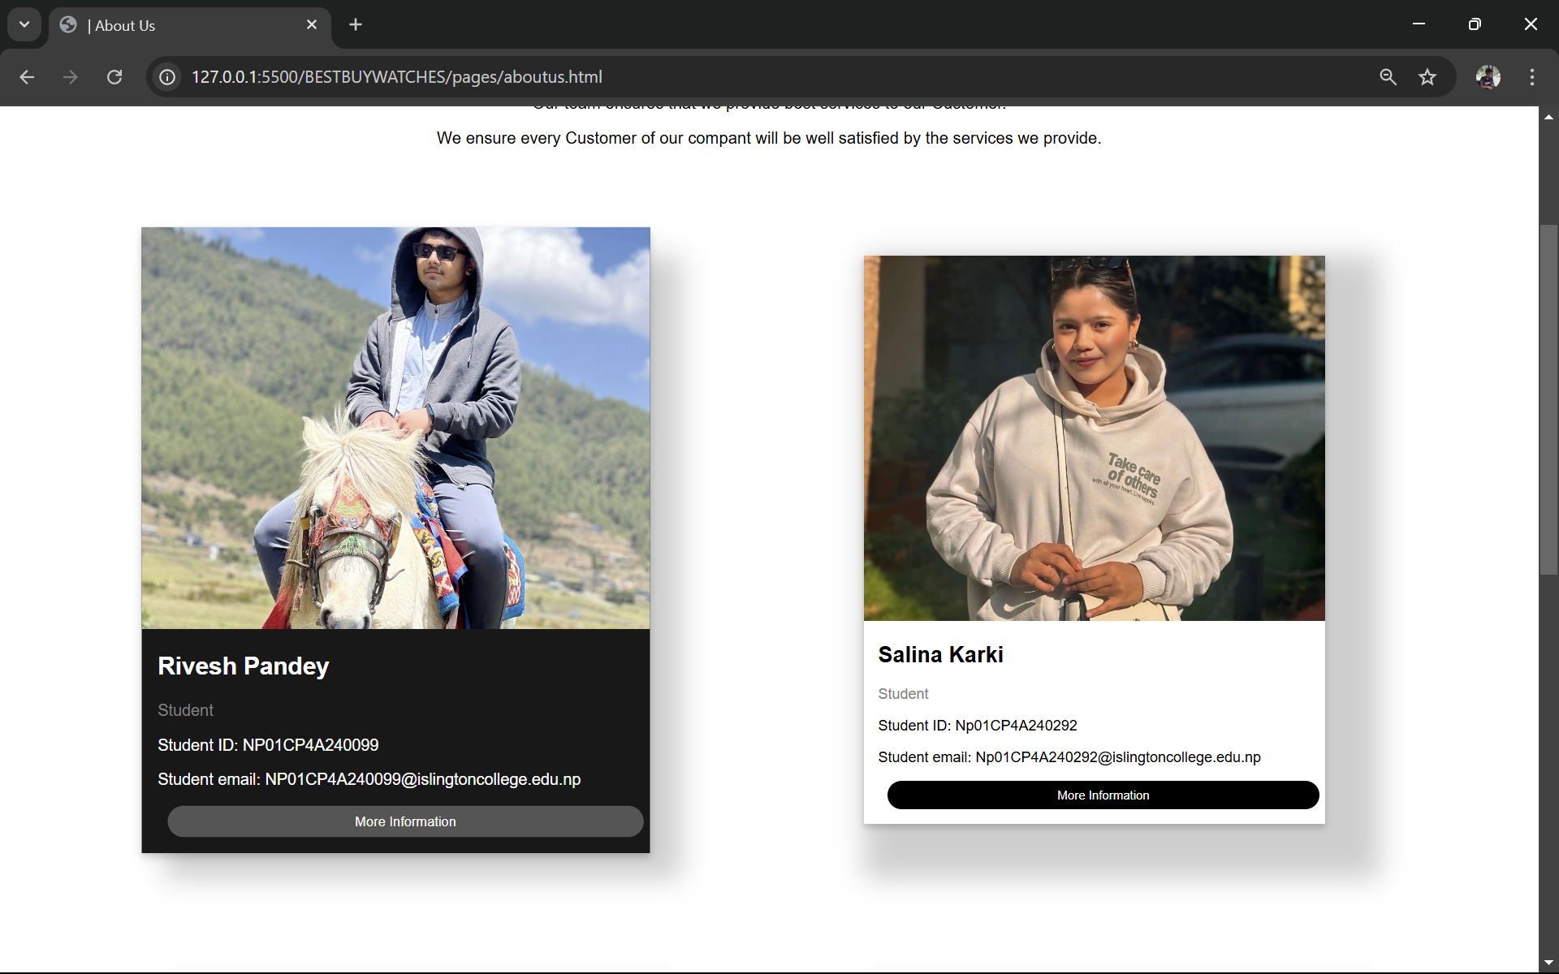

### 

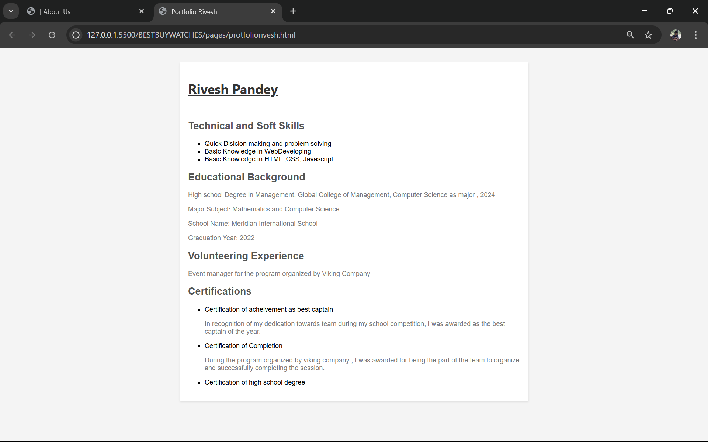

## Test 4.5: Internal Links

|  |  |
| --- | --- |
| Objective | To switch to another webpage using internal links. |
| Action | Click the Official Watch Website icon in blog page to open the  official websites of different companies |
| Expected Result | It will redirect to the respective profiles. |
| Actual Test | Opened the page. |
| Result | The test was successful. |

Table 5 Internal Links

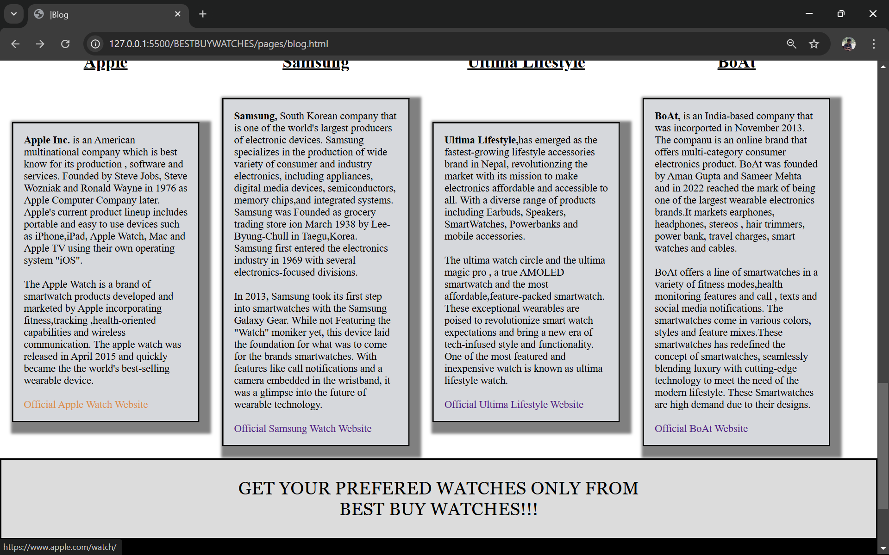

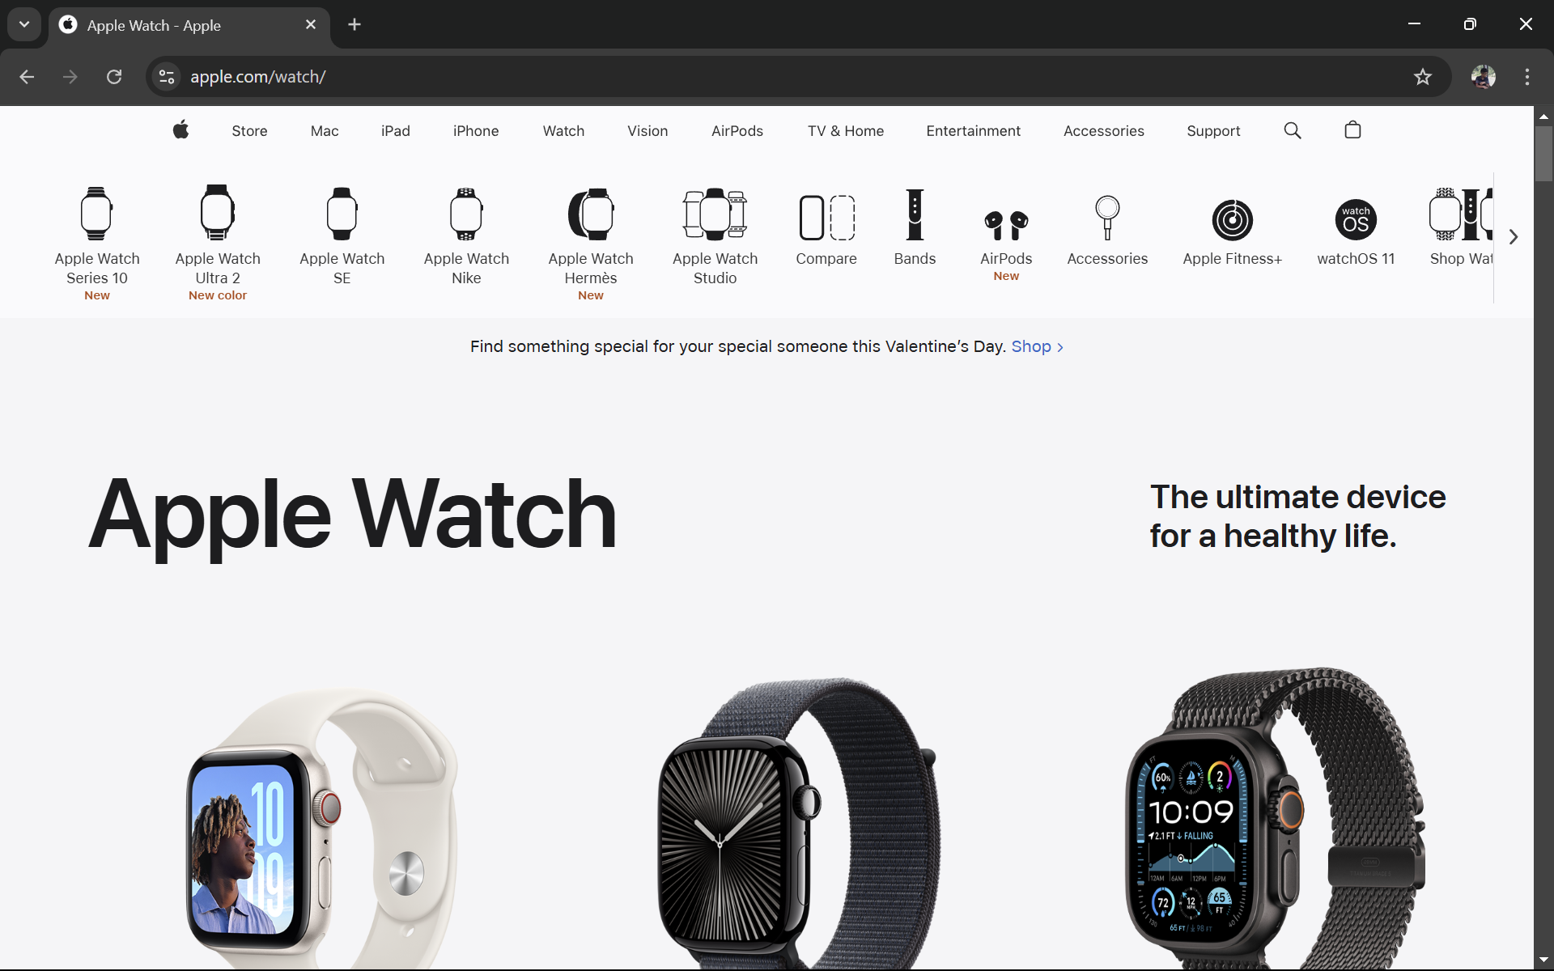

## Test 4.6: Add to Cart

|  |  |
| --- | --- |
| Objective | To display the message after adding it to the cart |
| Action | Select the preferred watch from product page, and click the add to  Cart button. |
| Expected Result | The Message “Added to Cart ”  Should be displayed. |
| Actual Test | Opened the page. |
| Result | The test was successful. |

Table 6 Add to Cart

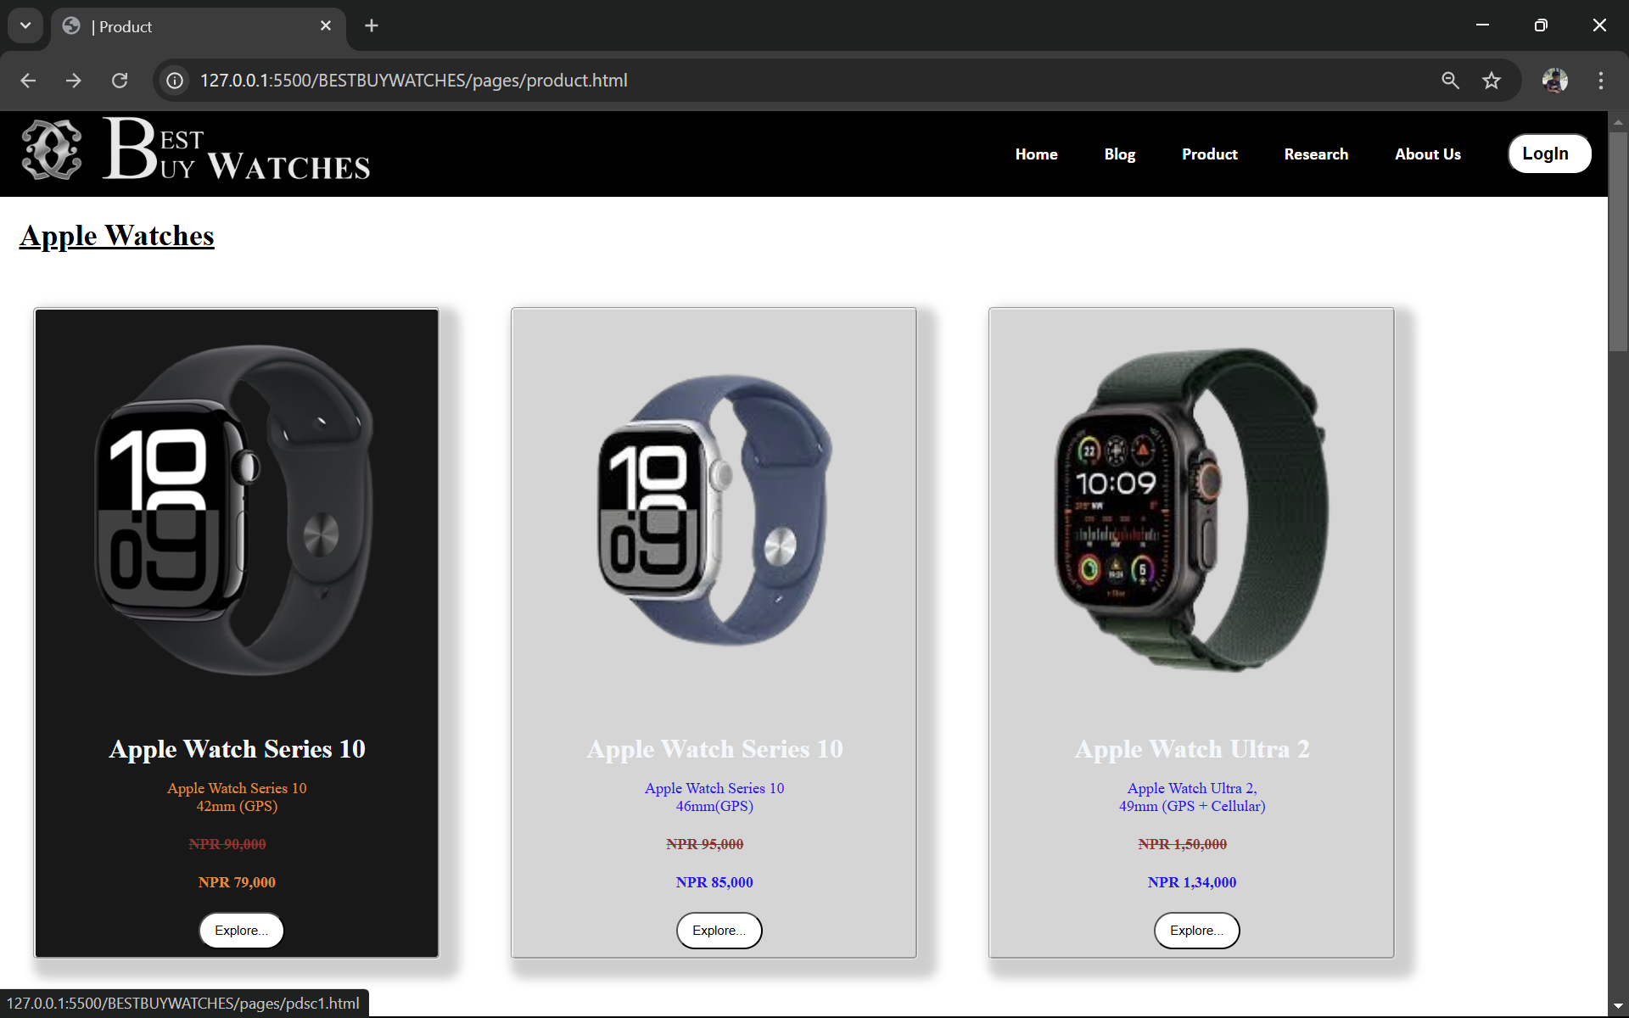

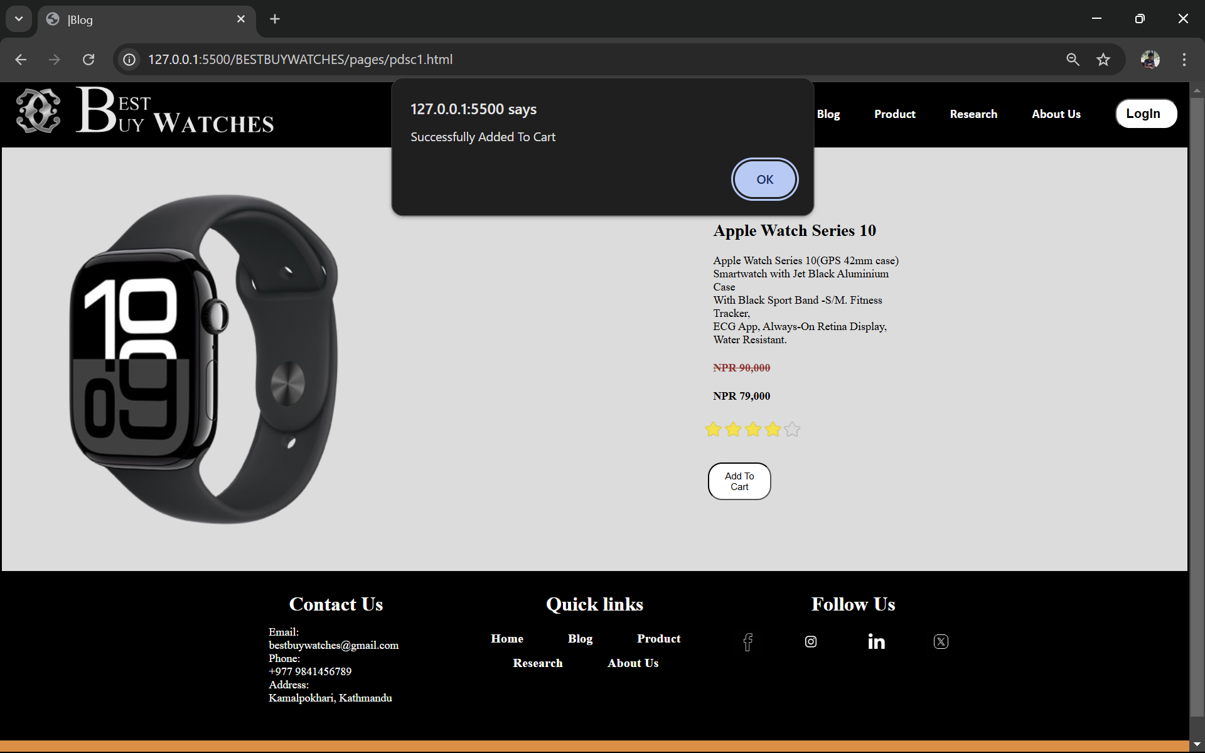

# CONCLUSION

After putting in a lot of effort into the coursework, the team finally completed the coursework in time. We learnt how to collaborate as a team for the first time since starting college because it was group assignment. We studied a variety of languages, including JavaScript, HTML and CSS. The coursework was very hard to start because of our lack of proper knowledge in the programming languages but we eventually completed the project using various resource materials on the internet. Code with Harry was an important YouTube channel that we used as reference to learn the programming languages properly. The courses were well explained and well documented by the owner of the channel.

Being this project as our first project of Islington College, creating an e-commerce website on watch topic was also slightly challenging. Because it was new to the group members to record a project in a group adjusting the project documentation was also a little difficult. Due to various mistakes in the project, the testing phase took a long time. Also, the fact that many of the reference websites lacked authors made the research required to record the project even more difficult. However, the coursework was eventually finished and polished for submission.

# References

Anon., n.d. s.l.:s.n.

Castro, E., 2003. *HTML for the world wide web..* s.l.:Peachpit Press.

Del Sole, A. a. S., 2019. *Visual Studio Code Distilled..* s.l.:Apress..

Flanagan, D., 2011. *JavaScript: The definitive guide: Activate your web pages..* s.l.: O'Reilly Media, Inc.

Grant, K. 2., 2024. *CSS in Depth.* Simon and Schuster: s.n.

Mohite, N. a. H. P., 2014. *Mockup To Web Page Conversion..* 3 ed. s.l.:International Journal of Engineering Research, .

# Appendix

## 7.1. Index.html

<!DOCTYPE html>

<html lang="en">

<head>

    <meta charset="UTF-8">

    <meta name="viewport" content="width=device-width, initial-scale=1.0">

    <title>| Home page</title>

    <link rel="stylesheet" href="css/index.css"> <!--ExternalCSS-->

    <script src="./javascript/java.js"></script>

<style> /* internal css*/

*{

    text-decoration:none;

  }

  html, body{

    padding: 0;

    margin: 0;

  overflow-x: hidden;

  font-family: Arial, Helvetica, sans-serif;

    min-height: 100%;

    display: flex;

    flex-direction: column;

  }

 .video-container{

    position: absolute;

    top: 0;

    left: 0;

    width: 100%;

    height: 100%;

    padding-bottom: -10%;

    z-index: -1;

    }

.background-video {

    object-fit: cover; /*  video covers the entire page */

    width: 100%;

    height: 100%;

    position: absolute;

    top: 0;

    left: 0;

}

.content {

    position: relative;

    z-index: 1;

    color: black;

    text-align: center;

    padding-top: 200px;

    font-family: Arial, sans-serif;

}

.Search{

    flex: 1;

    margin-left: 8%;

    display: flex;

    align-items: center;

}

/* Featured items section */

main {

    padding: 0px 70px;

  }

  .upper-main

    {

    padding-top: 10px;

    padding-bottom: 15px;

    margin-left: 20px;

    font-size: 30px;

    }

  .upper-main a{

    text-decoration: none;

  }

    .feturedcatagories

  {

    font-family: arial;

    padding-left: 10px;

    margin-top: 45%;

  }

  .catagoriesheader h2 {

    font-size: 40px;

    font-family:Arial, Helvetica, sans-serif;

    margin: 20px;

    padding-top: 62px;

    margin-left: -px;

  }

.featured-items {

  display: flex;

  flex-wrap: wrap;

  justify-content: space-between;

}

.item {

  width: 300px;

  margin-bottom: 30px;

  padding: 10px;

  box-shadow: 10px 10px 10px 10px rgba(10, 10, 10, 0.2);

  text-align: center;

}

.border

{

  margin: -2%;

}

.itemimage {

  background-color: #d5d5d5;

  height: 280px;

}

.itemname

{

  display: flex;

  background-color: #d1dbd3;

  padding: 0px 5px;

}

.itemarrow {

  content: "2192";

  color: dark black;

  margin-left: auto;

  font-size: 50px;

}

.item img {

  width: 100%;

  height: auto;

  border-radius: 5px;

  height: 100%;

  transition: transform 0.4s;

}

.itemimage:hover img {

  transform: scale(1.1);

}

.item h3 {

  font-size: 20px;

  margin-top: 10px;

}

/*

container section */

.descContainer{

  margin-bottom: 50px;

   background-color: #d1dbd3

  }

  .descSection{ /*section of body */

    display: flex;

    align-items: center;

    justify-content: space-between;

    padding-left: 20px;

    font-size: 35px;

  }

  .descSection img{

    max-width: 735px;

    height: 535px;

    margin-left: 20px;

  }

  .descSection-content{

    height: 100%;

  }

  .descSection-content h2{

    font-size: 45px;

    margin-bottom: 20px;

    text-align: center;

    text-decoration: underline;

  }

  .descSection-content p{

    font-size: 16px;

    line-height: 1.5;/*1.5x the size of a font*/

    margin-right: 30px;

    font-style: oblique;

 }

    </style>

</head>

<body onload="start()">

    <header>

        <!-- navbar -->

    <nav class="navbar">

        <div class = "navdiv">

            <div class="logo"> <a href="./index.html">  <img src="images/LOGO_IS-removebg-preview (1).png" alt="an image" width="80px" height="80px"> <img src="images/New_Microsoft_Word_Document__1__page-0002-removebg-preview.png" alt="an image" width="290px" height="80px"> </a> </div>  <!-- linked to homepage while clicking logo-->

            <div class="Search">

                <form>

                    <input type="text" placeholder="Search">

                    <button type="submit">Search</button>

                </form>

        </div>

            <ul> <!-- Unordered list -->

                <li> <a href="./index.html"> Home </a> </li> <!--link-->

                <li> <a href="./pages/blog.html"> Blog </a></li>

                <li> <a href="./pages/product.html"> Product</a></li>

                <li> <a href="./pages/research.html"> Research</a></li>

                <li> <a href="./pages/aboutus.html"> About Us </a></li>

                <button> <a href="./pages/loginpage.html" style="color: black; font-size: 18px; font-weight: bold; margin-right: 10px;">  LogIn </a> </button>

            </ul>

            </nav>

        </div>

  <div class=" video-container">

        <video class="background-video"  autoplay loop muted >

            <source src="video/Apple Watch Series 9 Reveal (4K) - Apple Spectrum (720p, h264).mp4" type="video/mp4">

            </style>

        </video>

    </div>

    </header>

  <main>

    <!-- featured product -->

    <div class="feturedcatagories">

      <div class="catagoriesheader">

        <h2 style="color: black;font-family: 'Times New Roman', Times, serif; font-size: 55px;"> FEATURED PRODUCTS</h2>

      </div>

      <br>

      <div class="featured-items">

        <div class="item">

          <a href="./pages/product.html" target="_blank">

          <div class="border">

            <div class="itemimage">

                <img src="./images/p1.png" alt=""></a>

            </div>

            <div class="itemname">

              <h3>Apple Watch Series 10</h3>

              <span class="itemarrow">&#8598;</span>

            </div>

          </div>

        </div>

        <div class="item">

          <div class="border">

            <div class="itemimage">

              <a href="./pages/product.html" target="_blank">

                <img src="./images/p3.png" alt="">

              </a>

            </div>

            <div class="itemname">

              <h3>Apple Watch Ultra 2</h3>

              <span class="itemarrow">&#8598;</span>

            </div>

          </div>

        </div>

        <div class="item">

          <div class="border">

            <div class="itemimage">

              <a href="./pages/product.html" target="_blank">

                <img src="./images/p5.png" alt="">

              </a>

            </div>

            <div class="itemname">

              <h3>Ultima Watch Nova Pro</h3>

              <span class="itemarrow">&#8598;</span>

            </div>

          </div>

        </div>

        <div class="item">

          <div class="border">

            <div class="itemimage">

              <a href="./pages/product.html" target="_blank">

                <img src="./images/p6.png" alt="">

              </a>

            </div>

            <div class="itemname">

              <h3>Ultima Magic Smart Watch</h3>

              <span class="itemarrow">&#8598;</span>

            </div>

          </div>

        </div>

        <div class="item">

          <div class="border">

            <div class="itemimage">

              <a href="./pages/product.html" target="_blank">

                <img src="./images/p8.png" alt="">

              </a>

            </div>

            <div class="itemname">

              <h3>Samsung Galaxy Watch FE</h3>

              <span class="itemarrow">&#8598;</span>

            </div>

          </div>

        </div>

        <div class="item">

          <div class="border">

            <div class="itemimage">

              <a href="./pages/product.html" target="_blank">

                <img src="./images/p10.png" alt="">

              </a>

            </div>

            <div class="itemname">

              <h3>boAt Wave Call 2</h3>

              <span class="itemarrow">&#8598;</span>

            </div>

          </div>

        </div>

        <div class="item">

          <div class="border">

            <div class="itemimage">

              <a href="./pages/product.html" target="_blank">

                <img src="./images/p12.png" alt="">

              </a>

            </div>

            <div class="itemname">

              <h3>boAt Storm Call</h3>

              <span class="itemarrow">&#8598;</span>

            </div>

          </div>

        </div>

        <div class="item">

          <div class="border">

            <div class="itemimage">

              <a href="./pages/product.html" target="_blank">

                <img src="./images/p2.png" alt="">

              </a>

            </div>

            <div class="itemname">

              <h3>Apple Watch Series 10</h3>

              <span class="itemarrow">&#8598;</span>

            </div>

          </div>

        </div>

      </div>

    </div>

    <br>

    <div class="descContainer">

      <!-- container for discription -->

      <div class="descSection">

        <div class="descSection-content">

          <h2>Description</h2>

          1. Home Page:<p>

            Experience the world of smart watches at Best Buy Watches. Discover a wide range of top quality Smart watches

            and all the accessories .staying updated with the latest technology and trends with the help of

            Watch community.

            <br>

          </p>

          2. Blog Page:<p>

            In our Blog page we covered the topic about Positive and negative impacts of technology on our daily

            lives and in business

            (impact of technology while selling  equipments ).stay informed with expert tips,exciting news,and

            how advancement in Smart watches changing everything.

            <br>

          </p>

          3. Product Page:<p>

            Uncover our diverse section of smart watches on the Product page.Explore various brands and new

            technologies.Each product is diffrentiated by its details like

            name, product price, discounted price, actual price.

            <br>

          </p>

          4. Research Section:<p>

            In our Research section, we have mentioned comparison of our webite with other industry leading webites

            (atleat 5 refrences)

            showcasing features and functionalities. we have learned from the best while making our website ensuring

            excellent user experience.

            <br>

          </p>

          5. About Us:<p>

            Get to know our team members through the About Us section where there is detailed portfolios,

            showcasing out technical expertise,educational background,volunteering experiences, certification and

            more.Learn about us how we are trying to make an outstanding customer service

            <br>

          </p>

        </div>

        <img src="./images/smartwatch.jpg" alt="Contact Image" width="1500px">

      </div>

    </div>

  </main>

    </main>

      <!-- footer -->

    <footer>

        <div class="container">

            <div class="footer-content">

                <h3> Contact Us</h3>

                <p> Email: bestbuywatches@gmail.com</p>

                <p> Phone:<br>

                    +977 9841456789</p>

                <p> Address:<br>

                     Kamalpokhari, Kathmandu</p>

            </div>

            <div class=" footer-content">

                <h3> Quick links</h3>

                <ul class="list">

                    <li> <a href="./index.html"> Home</a></li>

                    <li> <a href="./pages/blog.html"> Blog</a></li>

                    <li> <a href="./pages/product.html"> Product</a></li>

                    <li> <a href="./pages/research.html"> Research</a></li>

                    <li>  <a href="./pages/aboutus.html"> About Us</a></li>

                </ul>

            </div>

            <div class=" footer-content">

                <h3> Follow Us</h3>

                <ul class="social-icons">

                    <li> <a href="https://www.facebook.com/"> <img src="./images/f.png" alt="an image"></a></li> <!-- images used for an icon-->

                    <li> <a href="https://www.instagram.com/"> <img src="./images/i.png" alt="an image1"> </a></li>

                    <li> <a href="https://np.linkedin.com/">  <img src="./images/l.png" alt="an image2"></a></li>

                    <li> <a href="https://x.com/?lang=en&mx=2"> <img src="./images/x.png" alt= "an image3"></a></li>

                </ul>

            </div>

        </div>

                <div class="bottom-bar">

                    <p> &copy; 2025 Best Buy Watches . All rights reserved </p>

                    </div>

    </footer>

</body>

</html>

## 7.2. blog.html

<!DOCTYPE html>

<html lang="en">

<head>

    <meta charset="UTF-8">

    <meta name="viewport" content="width=device-width, initial-scale=1.0">

    <title>|Blog</title>

    <link rel="stylesheet" href="../css/index.css"> <!--ExternalCSS-->

     <style>

body{

    padding: 0;

    margin:0;}

.background

    {

    background-color:gainsboro;

    color:black;

    display: flex;

    border:solid black;

    margin-top: 25px;

    }

.split { display:flex}

.left{ flex: 70%;}

.right{flex: 30%;}

.center{flex: 50%; padding-left: 20px;}

.p {

        border:solid black;

            padding: 20px;

            margin: 20px;

            height:min-content;

            border-style:groove;

            background-color:#d5d8dc  ;

            font-size:20px;

            box-shadow: 10px 10px 5px 12px gray;

     }

.p1{border:solid black;

    padding: 20px;

    margin: 20px;

    height:min-content;

    border-style:inset;

    background-color:#d5d8dc  ;

    font-size:20px;

    box-shadow:  5px 5px 2px gray;

}

.h1{font-size: 60px;

    background-color:#f4f5ee;width: min-content;color:BLACK;

    }

 .h1_{

    font-size: 70px;

     background-color: black;width: min-content;color: white;}

.h1,.h1_{display: inline;  border: 5px outset;

}

.h2{

    font-size: 80px;}

.topic{

    font-size: 22px;}

.center1{

    text-align:center;

    background-color: gainsboro;

    border: solid black;}

.row {

    display: flex;}

.leftcolum{

    flex:75%}

.rightcolum{

     flex:25%;}

.card{

    background-color:#f4f5ee ;

    padding:20px;

    margin-top:20px;}

    </style>

</head>

<body>

    <section>

        <!-- navbar -->

    <nav class="navbar">

        <div class = "navdiv">

            <div class="logo"> <a href="../index.html">  <img src="../images/LOGO_IS-removebg-preview (1).png" alt="an image" width="80px" height="80px"> <img src="../images/New_Microsoft_Word_Document__1__page-0002-removebg-preview.png" alt="an image" width="290px" height="80px"> </a> </div>  <!-- linked to homepage while clicking logo-->

            <ul> <!-- Unordered list -->

                <li> <a href="../index.html"> Home </a> </li> <!--link-->

                <li> <a href="./blog.html"> Blog </a></li>

                <li> <a href="./product.html"> Product</a></li>

                <li> <a href="./research.html"> Research</a></li>

                <li> <a href="./aboutus.html"> About Us </a></li>

                <button > <a href="./loginpage.html" style="color: black; font-size: 18px; font-weight: bold; margin-right: 10px;">  LogIn </a> </button>

                </ul>

            </nav>

        </div>

    </section>

    <div style="background-image: url(../images/div.jpg); background-size: cover; background-repeat: no repeat; padding: 200px; "></div><br><br>

    <h1  class="h1_">BLOG: </h1>

    <h1  class="h1">TO WATCH</h1>

    <section class="background" >

        <div class="split left">

            <div>

            <h2  class ="h2" style="font-family:'Lucida Sans', 'Lucida Sans Regular', 'Lucida Grande', 'Lucida Sans Unicode', Geneva, Verdana, sans-serif ;color:brown;text-align: center;padding: 45px;">

                WHY ALWAYS <BR>  BEST BUY   WATCHES?

            </h2>

            <h2 class="h2" style="font-family: 'Lucida Sans', 'Lucida Sans Regular', 'Lucida Grande', 'Lucida Sans Unicode', Geneva, Verdana, sans-serif ;text-align: center;padding: 20px;">

                "Unlock Your Potential: Elevate Every Moment with the SmartWatch"</h2>

            </div>

            </div>

            </div>

    <div class="split right ">

        <p style="font-family:'Times New Roman', Times, serif ; font-size: 35px;"> <b>Latest, Easiest and Fastest</b> e-commerce site

            for the purchase of smart watches for the people.<br>

             Only delivers and provides the latest lunch watches  since 2024.

        <br>Best Buy Watches is an convenience , easy to navigate website for purchasing of watches from all over the world.

        <br>Also often offers competitive pricing,deals, discounts and seasonal sales making it budget-friendly option for many consumers.

        <br>

            Builds trust and reduces the risk of dissatisfactions.<br><b>Your Wrist, Our Watch!</b> </p>

    </div>

</section>

<div>

<br><hr>

<br><br>

<div class="row">

    <div class="left colom">

        <div class="card p1" style ="font-size: 23px;">

            <h2 style="color: brown;">EVOLUTION OF WATCH TECHNOLOGY </h2>

            <p>Since their creation,watches have dazzled onlookers with their complex mechanisms and cutting-edge technology.

                Wastches have always stimulated the imagination and benefited the wearer, whether they are high tech mechanical devices

                driven by gravity or precise pendants that need to be wounf constantly. The most

                common usage of modern timepieces may be as expensive fashion ornaments, but underneath the dial is a fascinating history.

            </p>

        </div>

        <div class="card p1" style="font-size:23px ;">

            <h2 style="color: brown;">BOOST OF SALES</h2>

            <p>Time is everything. People need to wear a watch to keep up with their appointments, set goals, meet deadlines, and check how

               much time they have left to finish a task. Watches come in different designs, colors, and mechanisms, but they all play one

               role ,i.e telling the right time.<br><br>

               Ellaborating the online market or the online stores showcases watches to global audience, enhancing visibility and sales potential.

               Today its very easy with AI-driven tools to reach specific required watch on their preferences. Trend of collaborations among companies

               and well know people is able to introduce innovative features and attract tech enthusiasts. Todays sales force doesn't necessarily need to face-to-face

               to make a sales presentation. Softwares allow the salesperson to create a short presentation that customers can watch at their convenience.

               For expansion,businesses also rely on acquiring and keeping customers. A consistently high level of customer service provides the company to keep their customers

               within them or around them.

            </div>

            </p>

    </div>

    <div class="right colom">

        <div class="card p1" style ="font-size: 22px;">

            <h2 style="color: brown;">THE RISE OF SMARTWATCHES</h2>

            <p>Smartwatches have emerged as a significant player in the wearable technology market. One of the primary attractions of

                smartwatches is their ability to integrate seamlessly with smartphones.Users can receive calls,read messages, and even

                respont to them directly from their wriests,eliminating the need to constantly check their phones.

            </p>

        </div>

        <div class="card p1" style ="font-size: 22px;">

            <h2 style="color: brown;">OVERALL CONCLUSION</h2>

            <p> The watch business has undergone a transformation thanks to technology, which has a turned conventional timepieces into multipurpose

                devices that meet contemporary needs. Although there is no denying the advantages of technological integration, there are drawbacks as well.

            </p>

        </div>

    </div>

</div>

<table >

    <tr class="topic" >

        <th width="400" class="topic" ><h2><u>Apple</u></h2></th>

        <th width="400" class="topic"><h2><u>Samsung</u></h2></th>

        <th width="400" class="topic"><h2><u>Ultima Lifestyle</u></h2></th>

        <th width="400" class="topic"><h2><u>BoAt</u></h2></th>

    </tr>

    <tr>

        <td >

            <p class="p" >

                <b>Apple Inc.</b> is an American multinational company which is best know for its production , software and services.

                   Founded by Steve Jobs, Steve Wozniak and Ronald Wayne in 1976 as Apple Computer Company later. Apple's current product

                   lineup includes portable and easy to use devices such as iPhone,iPad, Apple Watch, Mac and Apple TV using their own

                   operating system "iOS".<br><br> The Apple Watch is a brand of smartwatch products developed and marketed by Apple incorporating

                   fitness,tracking ,health-oriented capabilities and wireless communication. The apple watch was released in April 2015 and quickly

                   became the the world's best-selling wearable device.<br><br><a href="https://www.apple.com/watch/"<b>Official Apple Watch Website</b>

            </p>

        </td>

        <td>

            <p class="p">

                <b>Samsung,</b> South Korean company that is one of the world's largest producers of electronic devices. Samsung specializes in the production

                   of wide variety of consumer and industry electronics, including appliances, digital media devices, semiconductors, memory chips,and integrated systems.

                   Samsung was Founded as grocery trading store ion March 1938 by Lee-Byung-Chull in Taegu,Korea.

                   Samsung first entered the electronics industry in 1969 with several electronics-focused divisions.<br><br>

                   In 2013, Samsung took its first step into smartwatches with the Samsung Galaxy Gear. While not Featuring the "Watch" moniker yet, this device laid the foundation

                   for what was to come for the brands smartwatches. With features like call notifications and a camera embedded in the wristband, it was a glimpse into the future of

                   wearable technology.<br><br>

                   <a href="https://www.samsung.com/us/watches/"<b>Official Samsung  Watch Website</b>

            </p>

        </td>

        <td>

            <p class="p">

                <b>Ultima Lifestyle,</b>has emerged as the fastest-growing lifestyle accessories brand in Nepal, revolutionzing the market with its mission to make electronics

                affordable and accessible to all. With a diverse range of products including Earbuds, Speakers, SmartWatches, Powerbanks and mobile accessories. <br><br>

                The ultima watch circle and the ultima magic pro , a true AMOLED smartwatch and the most affordable,feature-packed smartwatch. These exceptional wearables are

                 poised to revolutionize smart watch expectations and bring a new era of tech-infused style and functionality. One of the most featured and inexpensive watch is

                 known as ultima lifestyle watch.

                 <br><br>  <a href="https://ultima.com.np/product-category/smartwatch/"<b>Official Ultima Lifestyle Website</b>

            </p>

        </td>

        <td>

            <p class="p">

                <b>BoAt,</b> is an India-based company that was incorported in November 2013. The companu is an online brand that offers multi-category consumer electronics product.

                   BoAt was founded by Aman Gupta and Sameer Mehta and in 2022 reached the mark of being one of the largest wearable electronics brands.It markets earphones, headphones,

                   stereos , hair trimmers, power bank, travel charges, smart watches and cables.<br><br>

                   BoAt offers a line of smartwatches in a variety of fitness modes,health monitoring features and call , texts and social media notifications. The smartwatches come in

                   various colors, styles and feature mixes.These smartwatches has redefined the concept of smartwatches, seamlessly blending luxury with cutting-edge technology to meet

                   the need of the modern lifestyle. These Smartwatches are high demand due to their designs.<br><br>

                   <a href="https://www.boat-lifestyle.com/"<b>Official BoAt Website</b>

            </p>

        </td>

    </tr>

</table>

</div>

<section class="center1" >

    <p style="font-family: Georgia, 'Times New Roman', Times, serif;font-size: 35px; text-align:center"  >

       GET YOUR PREFERED WATCHES ONLY FROM <BR> BEST BUY WATCHES!!!

    </p>

</section>

      <!-- footer -->

      <footer>

        <div class="container">

            <div class="footer-content">

                <h3> Contact Us</h3>

                <p> Email: bestbuywatches@gmail.com</p>

                <p> Phone:<br>

                    +977 9841456789</p>

                <p> Address:<br>

                     Kamalpokhari, Kathmandu</p>

            </div>

            <div class=" footer-content">

                <h3> Quick links</h3>

                <ul class="list">

                    <li> <a href="../index.html"> Home</a></li>

                    <li> <a href="../pages/blog.html"> Blog</a></li>

                    <li> <a href="../pages/product.html"> Product</a></li>

                    <li> <a href="./aboutus.html"> Research</a></li>

                    <li>  <a href="./aboutus.html"> About Us</a></li>

                </ul>

            </div>

            <div class=" footer-content">

                <h3> Follow Us</h3>

                <ul class="social-icons">

                    <li> <a href="https://www.facebook.com/"> <img class="" src="../images/f.png" alt="an image"></a></li> <!-- images used for an icon-->

                    <li> <a href="https://www.instagram.com/"> <img src="../images/i.png" alt="an image1"> </a></li>

                    <li> <a href="https://np.linkedin.com/">  <img src="../images/l.png" alt="an image2"></a></li>

                    <li> <a href="https://x.com/?lang=en&mx=2"> <img src="../images/x.png" alt= "an image3"></a></li>

                </ul>

            </div>

        </div>

                <div class="bottom-bar">

                    <p> &copy; 2025 Best Buy Watches . All rights reserved </p>

                    </div>

    </footer>

</body>

</html>

## 7.3. product.html

<!DOCTYPE html>

<html>

    <head>

<title>| Product</title>

<meta name="Products" content="image">

<link rel="stylesheet" href="../css/index.css"> <!--ExternalCSS-->

<style>

 body{

    padding: 0;

    margin:0;

 }

.product{

    width: 25%;

    display: inline-block;

    background-color: #d5d5d5;

    border-radius: 5px;

    margin: 35px;

    border-style: groove;

    box-shadow: 10px 10px 10px 10px rgba(10, 10, 10, 0.2);

}

.border{

    margin: 2%;

}

.desc{

    text-align: center;

}

.title{

    text-align: center;

    color: rgb(243, 247, 250);

}

.image img{

    width: 100%;

    height: 25%;

    border-radius: 5px;

    transition: transform 0.4s;

}

.product:hover{

background-color: rgb(25, 24, 24);

color: white

}

.discounted-price{

    text-align: center;

}

.button{

    margin-top: 10px;

    margin-bottom: 10px;

    background-color: grey;

    border: 1px solid black;

    padding: 30px;

}

.image:hover img{

    transform: scale(1.1);

}

button:hover{

    background-color: black;

    color: white;

    transition: 1s;

}

.body {

    background-color: transparent;

}

.background {

    /* background-image: url(../images/LOGO_IS-removebg-preview\ \(1\).png); */

    background-color:whitesmoke;

}

.h1{

    margin-left:20px;

}

</style>

    </head>

    <body>

        <header>

        <!-- navbar -->

        <nav class="navbar">

            <div class = "navdiv"> <!--div class for nav bar -->

                <div class="logo"> <a href="../index.html">  <img src="../images/LOGO_IS-removebg-preview (1).png" alt="an image" width="80px" height="80px"> <img src="../images/New_Microsoft_Word_Document__1__page-0002-removebg-preview.png" alt="an image" width="290px" height="80px"> </a> </div>  <!-- linked to homepage while clicking logo-->

                <ul> <!-- Unordered list -->

                    <li> <a href="../index.html"> Home </a> </li> <!--link-->

                    <li> <a href="./blog.html"> Blog </a></li>

                    <li> <a href="./product.html"> Product</a></li>

                    <li> <a href="./research.html"> Research</a></li>

                    <li> <a href="./aboutus.html"> About Us </a></li>

                    <button> <a href="./loginpage.html" style="color: black; font-size: 18px; font-weight: bold; margin-right: 10px;">  LogIn </a> </button>

                    </ul>

                </nav>

            </div>

        </header>

            <h1 class="h1"><u>Apple Watches</u> </h1>

            <div class="main"> <!--main div -->

    <div class="product"><a href="../pages/pdsc1.html"><!-- div class for product box section -->

        <div class=" border"><!--div class for border of box -->

        <div class="image"><!-- div class for image inside product box-->

            <img src="../images/p1.png"  height="150px" width="180px" >

        </div>

        <div class="title">

            <h3>Apple Watch Series 10</h3> <!--Product Title -->

        </div>

        <div class="desc">

            <p>Apple Watch Series 10  <br>42mm (GPS)</p>

        </div>

        <div class="discounted-price">

            <h4 style="text-decoration: line-through; padding-right: 20px; color: brown;">NPR 90,000</h4>

            <h4>NPR 79,000</h4>

            <button>Explore...</button>

        </div>

        </div>

    </a>

       <!--class for apple-->

      </div>

      <div class="product"><a href="../pages/pdsc2.html">

        <div class=" border">

        <div class="image">

            <img src="../images/p2.png" alt=""   height="150px" width="180px">

        </div>

        <div class="title">

            <h3>Apple Watch Series 10</h3>

        </div>

        <div class="desc">

          <p>Apple Watch Series 10 <br>46mm(GPS)</p>

        </div>

        <div class="discounted-price">

            <h4 style="text-decoration: line-through; padding-right: 20px; color: brown;">NPR 95,000</h4>

            <h4>NPR 85,000</h4>

            <button>Explore...</button>

        </div>

    </div>

    </div>

</a>

    <!--class for apple-->

    <div class="product"> <a href="../pages/pdsc3.html">

        <div class=" border">

        <div class="image">

            <img src="../images/p3.png" height="150px" width="180px">

        </div>

        <div class="title">

            <h3>Apple Watch Ultra 2</h3>

        </div>

        <div class="desc">

          <p>Apple Watch Ultra 2,<br>

            49mm (GPS + Cellular) </p>

        </div>

        <div class="discounted-price">

            <h4 style="text-decoration: line-through; padding-right: 20px; color: brown;">NPR 1,50,000</h4>

            <h4>NPR 1,34,000</h4>

            <button>Explore...</button>

        </div>

        </div>

    </div>

</a>

</div>

<!--class for apple -->

<h1 class="h1"><u>Ultima Watches</u></h1>

<div class="product">

    <div class=" border">

    <div class="image">

        <img src="../images/p4.png"     height="150px" width="180px">

    </div>

    <div class="title">

        <h3>Ultima Watch Flex</h3>

    </div>

    <div class="desc"><!--div for description -->

      <p>2.01-inch HD Display, Ultima Fit App, Advanced SingleSync Bluetooth Calling,

        <br>24/7 health tracking, 100+ sports modes</p>

    </div>

    <div class="discounted-price">

        <h4 style="text-decoration: line-through; padding-right: 20px; color: brown;">NPR 5,000</h4>

        <h4>NPR 4,000</h4><!-- making discounted price -->

        <button>Explore...</button>

    </div>

    </div>

</div>

<!--class for ultima flex-->

<div class="product">

    <div class=" border">

    <div class="image">

        <img src="../images/p5.png" height="150px" width="180px">

    </div>

    <div class="title">

        <h3>Ultima Watch Nova Pro</h3>

    </div>

    <div class="desc">

      <p>2.04″ Amoled Display, Bluetooth Calling, Health & Sports Tracking.<br> Available in Black, Silver & Pink.

         </p>

    </div>

    <div class="discounted-price">

        <h4 style="text-decoration: line-through; padding-right: 20px; color: brown;">NPR 6,000</h4>

        <h4>NPR 4,999</h4>

        <button>Explore...</button>

    </div>

    </div>

</div>

<!--class Ultima Nova Pro-->

<div class="product">

    <div class=" border">

    <div class="image">

        <img src="../images/p6.png" height="100px" width="150px">

    </div>

    <div class="title">

        <h3>Ultima Magic </h3>

    </div>

    <div class="desc">

      <p> Premium design, 500 Nits display, 110+ sports modes, and more.<br>

        Your ultimate companion </p>

    </div>

    <div class="discounted-price">

        <h4 style="text-decoration: line-through; padding-right: 20px; color: brown;">NPR 7,000</h4>

        <h4>NPR 3,999</h4>

        <button>Explore...</button>

    </div>

    </div>

</div>

<!--class Ultima Smart watch-->

<h1 class="h1" ><u>Samsung Watches</u></h1>

<div class="main">

<div class="product">

    <div class=" border">

    <div class="image">

        <img src="../images/p7.png" height="150px" width="180px">

    </div>

    <div class="title">

        <h3>Samsung Galaxy Fit3</h3>

    </div>

    <div class="desc">

      <p> 1.6 inches Amoled Display, Resolution

        256 x 402 Pixels, Size: 40 mm

        Material: Plastic</p>

    </div>

    <div class="discounted-price">

        <h4 style="text-decoration: line-through; padding-right: 20px; color: brown;">NPR 8,000</h4>

        <h4>NPR 5,999</h4>

        <button>Explore...</button>

    </div>

    </div>

</div>

<!--class samsung first one-->

<div class="product">

    <div class=" border">

    <div class="image">

        <img src="../images/p8.png" height="150px" width="180px">

    </div>

    <div class="title">

        <h3>Samsung Galaxy Watch FE</h3>

    </div>

    <div class="desc">

      <p> 1.2 inches Amoled Display, resolution

        396 x 396 pixels, Size:40mm

         </p>

    </div>

    <div class="discounted-price">

        <h4 style="text-decoration: line-through; padding-right: 20px; color: brown;">NPR 90,000</h4>

        <h4>NPR 40,999</h4>

        <button>Explore...</button>

    </div>

    </div>

</div>

<!--class 2nd one-->

<div class="product">

    <div class=" border">

    <div class="image">

        <img src="../images/p9.png" height="150px" width="180px">

    </div>

    <div class="title">

        <h3>Samsung Galaxy Watch 6</h3>

    </div>

    <div class="desc">

      <p> Size: (40mm,44mm), Material: Aluminum, 1.31 inches Super Amoled Display</p>

    </div>

    <div class="discounted-price">

        <h4 style="text-decoration: line-through; padding-right: 20px; color: brown;">NPR 1,00,000</h4>

        <h4>NPR 49,999</h4>

        <button>Explore...</button>

    </div>

    </div>

</div>

    <!--class samsung 3rd one-->

    <h1 class="h1"><u>boAt Watches </u></h1>

    <div class="main">

    <div class="product">

     <div class=" border">

        <div class="image">

            <img src="../images/p10.png"height="150px" width="180px">

        </div>

        <div class="title">

            <h3>boAt Wave Call 2 </h3>

        </div>

        <div class="desc">

          <p> 1.83 inches LCD display, 240 x 284 pixels resolution, Bluetooth calling, Notifications,

            Music and Camera control, Timer, Stopwatch, Alarms, Find My Phone </p>

        </div>

        <div class="discounted-price">

            <h4 style="text-decoration: line-through; padding-right: 20px; color: brown;">NPR 5,000</h4>

            <h4>NPR 3,999</h4>

            <button>Explore...</button>

        </div>

        </div>

    </div>

    <!--class wave call 2-->

    <div class="product">

        <div class=" border">

        <div class="image">

            <img src="../images/p11.png" height="150px" width="180px">

        </div>

        <div class="title">

            <h3>boAt Wave Hype</h3>

        </div>

        <div class="desc">

          <p> 1.85 inches LCD Display, 240 x 280 pixels resolution, 24/7 Heart Rate Monitor,

             SpO2 (Blood Oxygen) Monitor, Breathe, Calorie Count, Sleep, Step </p>

        </div>

        <div class="discounted-price">

            <h4 style="text-decoration: line-through; padding-right: 20px; color: brown;">NPR 7,000</h4>

            <h4>NPR 4,999</h4>

            <button>Explore...</button>

        </div>

        </div>

    </div>

    <!--class Wave Hype-->

    <div class="product">

        <div class=" border">

        <div class="image">

            <img src="../images/p12.png" height="150px" width="180px">

        </div>

        <div class="title">

            <h3>boAt Storm Call </h3>

        </div>

        <div class="desc">

          <p>1.69 inches LCD Display, 220mAh Battery, 24/7 Heart Rate Monitor,

            SpO2 (Blood Oxygen) Monitor, Breathe, Calorie Count, Sleep, Step  </p>

        </div>

        <div class="discounted-price">

            <h4 style="text-decoration: line-through; padding-right: 20px; color: brown;">NPR 9,000</h4>

            <h4>NPR 6,999</h4>

            <button>Explore...</button>

        </div>

        </div>

    </div>

</div>

            <!--class for boAt 3rd-->

    </div>

        <!-- footer -->

        <footer>

            <div class="container">

                <div class="footer-content">

                    <h3> Contact Us</h3>

                    <p> Email: bestbuywatches@gmail.com</p>

                    <p> Phone:<br>

                        +977 9841456789</p>

                    <p> Address:<br>

                         Kamalpokhari, Kathmandu</p>

                </div>

                <div class=" footer-content">

                    <h3> Quick links</h3>

                    <ul class="list">

                        <li> <a href="../index.html"> Home</a></li>

                        <li> <a href="./blog.html"> Blog</a></li>

                        <li> <a href="./product.html"> Product</a></li>

                        <li> <a href="./research.html"> Research</a></li>

                        <li>  <a href="./aboutus.html"> About Us</a></li>

                    </ul>

                </div>

                <div class=" footer-content">

                    <h3> Follow Us</h3>

                    <ul class="social-icons">

                        <li> <a href="https://www.facebook.com/"> <img src="../images/f.png" alt="an image"></a></li> <!-- images used for an icon-->

                        <li> <a href="https://www.instagram.com/"> <img src="../images/i.png" alt="an image1"> </a></li>

                        <li> <a href="https://np.linkedin.com/">  <img src="../images/l.png" alt="an image2"></a></li>

                        <li> <a href="https://x.com/?lang=en&mx=2"> <img src="../images/x.png" alt= "an image3"></a></li>

                    </ul>

                </div>

            </div>

                    <div class="bottom-bar">

                        <p> &copy; 2025 Best Buy Watches . All rights reserved </p>

                        </div>

    </body>

    </html>

## 7.4. research.html

<!DOCTYPE html>

<html lang="en">

<head>

    <meta charset="UTF-8">

    <meta name="viewport" content="width=device-width, initial-scale=1.0">

    <title> | Research</title>

    <link rel="stylesheet" href="../css/index.css"> <!--ExternalCSS-->

    <style> /* internal css*/

*{

    text-decoration:none;

  }

  html, body{

    padding: 0;

    margin: 0;

  overflow-x: hidden;

  font-family: Arial, Helvetica, sans-serif;

    min-height: 100%;

    display: flex;

    flex-direction: column;

}

.refrencebox {

  margin-top: 2rem;

  display: flex;

  gap: 0.7rem;

  align-items: center;

  flex-direction: column;

  /*manages the pic in column  */

  color: white;

}

.refboxes {

  display: flex;

  align-items: center;

  gap: 8px;

}

.sshot {

            background-color: #727a7779;

            padding: 10px;

            border-radius: 10px 10px 10px 10px;

}

h1{

    text-align: center; color: brown;font-family: 'Lucida Sans', 'Lucida Sans Regular', 'Lucida Grande', 'Lucida Sans Unicode', Geneva, Verdana, sans-serif;

}

    </style>

    </head>

    <body>

    <!-- navbar -->

    <nav class="navbar">

        <div class = "navdiv">

            <div class="logo"> <a href="../index.html">  <img src="../images/LOGO_IS-removebg-preview (1).png" alt="an image" width="80px" height="80px"> <img src="../images/New_Microsoft_Word_Document__1__page-0002-removebg-preview.png " alt="an image" width="290px" height="80px"> </a> </div>  <!-- linked to homepage while clicking logo-->

            <ul> <!-- Unordered list -->

                <li> <a href="../index.html"> Home </a> </li> <!--link-->

                <li> <a href="./blog.html"> Blog </a></li>

                <li> <a href="./product.html"> Product</a></li>

                <li> <a href="./research.html"> Research</a></li>

                <li> <a href="./aboutus.html"> About Us </a></li>

                <button> <a href="./loginpage.html" style="color: black; font-size: 18px; font-weight: bold; margin-right: 10px;">  LogIn </a> </button>

            </ul>

    </nav>

    <br><br>

    <h1><i>The refrences of our website is given below :</i></h1>

    <div class="refrencebox">

        <!-- Div 1 -> Homepage-->

        <div class="refboxes">

            <div class="sshot">

                <h3>Our Website-Homepage</h3>

                <a href="http://127.0.0.1:5501/index.html" target="_blank">

                    <img src="../images/homepage.jpg" width="720" height="501" alt="OurHomepagesshot">

                  </a>

                </div>

            <div class="sshot">

                <h3>Reference Website-Homepage</h3>

                <a href="https://www.rolex.com/en-us" target="_blank">

                    <img src="../images/homepage ref.jpg" width="720" height="501" alt="ReferenceHomepagesshot">

                  </a>

            </div>

        </div>

        <br>

        <!-- Div 2 -> blog-->

        <div class="refboxes">

            <div class="sshot">

                <h3>Our Website-Blog</h3>

                <a href="http://127.0.0.1:5501/pages/blog.html" target="_blank">

                    <img src="../images/blog.png" width="720" height="501" alt="OurBlogsshot">

                  </a>

            </div>

            <div class="sshot">

                <h3>Reference Website</h3>

                <a href="https://zapier.com/" target="_blank">

                    <img src="../images/blogpage ref.jpg" width="720" height="501" alt="ReferenceBlogsshot">

                  </a>

            </div>

        </div>

        <br>

        <!-- Div 3 -> Products-->

        <div class="refboxes">

            <div class="sshot">

                <h3>Our Website-Product</h3>

                <a href="http://127.0.0.1:5501/pages/product.html" target="_blank">

                    <img src="../images/product.png" width="720" height="501" alt="OurProductssshot">

                  </a>

            </div>

            <div class="sshot">

                <h3>Reference Website</h3>

                <a href="https://www.daraz.com.np/#?" target="_blank">

                    <img src="../images/product ref.jpg" width="720" height="501" alt="ReferenceProductssshot">

                  </a>

            </div>

        </div>

        <br>

          <!-- Div 4 -> About Us-->

          <div class="refboxes">

            <div class="sshot">

                <h3>Our Website-AboutUs</h3>

                <a href="http://127.0.0.1:5501/pages/aboutus.html" target="_blank">

                    <img src="../images/aboutus.png" width="720" height="501" alt="OurAboutUssshot">

                  </a>

            </div>

            <div class="sshot">

                <h3>Reference Website</h3>

                <a href="https://www.namecheap.com/" target="_blank">

                    <img src="../images/about us ref.jpg" width="720" height="501" alt="ReferenceAboutussshot">

                  </a>

            </div>

        </div>

        <br>

        <!-- Div 5 -> Login Page-->

        <div class="refboxes">

            <div class="sshot">

                <h3>Our Website-AboutUs</h3>

                <a href="../pages/loginpage.html" target="_blank">

                    <img src="../images/login.png" width="720" height="501" alt="OurAboutUssshot">

                  </a>

            </div>

            <div class="sshot">

                <h3>Reference Website</h3>

                <a href="https://app.simplelogin.io/auth/login" target="_blank">

                    <img src="../images/login ref .png" width="720" height="501" alt="ReferenceAboutussshot">

                  </a>

            </div>

        </div>

        </div>

        <br>

          <!-- footer -->

          <footer>

            <div class="container">

                <div class="footer-content">

                    <h3> Contact Us</h3>

                    <p> Email: bestbuywatches@gmail.com</p>

                    <p> Phone:<br>

                        +977 9841456789</p>

                    <p> Address:<br>

                         Kamalpokhari, Kathmandu</p>

                </div>

                <div class=" footer-content">

                    <h3> Quick links</h3>

                    <ul class="list">

                        <li> <a href="../index.html"> Home</a></li>

                        <li> <a href="./blog.html"> Blog</a></li>

                        <li> <a href="./product.html"> Product</a></li>

                        <li> <a href="./research.html"> Research</a></li>

                        <li>  <a href="./aboutus.html"> About Us</a></li>

                    </ul>

                </div>

                <div class=" footer-content">

                    <h3> Follow Us</h3>

                    <ul class="social-icons">

                        <li> <a href="https://www.facebook.com/"> <img src="../images/f.png" alt="an image" ></a></li> <!-- images used for an icon-->

                        <li> <a href="https://www.instagram.com/"> <img src="../images/i.png" alt="an image1"> </a></li>

                        <li> <a href="https://np.linkedin.com/">  <img src="../images/l.png" alt="an image2"></a></li>

                        <li> <a href="https://x.com/?lang=en&mx=2"> <img src="../images/x.png" alt= "an image3"></a></li>

                    </ul>

                </div>

            </div>

                    <div class="bottom-bar">

                        <p> &copy; 2025 Best Buy Watches . All rights reserved </p>

                        </div>

        </footer>

    </body>

    </html>

## 7.6. loginpage.html

<!DOCTYPE html>

<html lang="en">

<head>

  <meta charset="UTF-8">

  <meta name="viewport" content="width=device-width, initial-scale=1.0">

  <title>Login</title>

  <script src="../javascript/java.js"></script>

  <style>

    body {

      font-family: Arial, sans-serif;

      background-color: #eef2f7;

      margin: 0;

      padding: 0;

      display: flex;

      justify-content: center;

      align-items: center;

      height: 100vh;

    }

    .form-box {

      background: #fff;

      padding: 30px;

      width: 400px;

      box-shadow: 0 4px 10px rgba(0, 0, 0, 0.1);

      border-radius: 10px;

      text-align: center;

    }

    h2 {

      color: #333;

    }

    form {

      display: flex;

      flex-direction: column;

    }

    label {

      text-align: left;

      font-weight: bold;

      margin-top: 10px;

    }

    input {

      width: 100%;

      padding: 10px;

      margin-top: 5px;

      margin-bottom: 15px;

      font-size: 16px;

      border: 1px solid #ccc;

      border-radius: 5px;

      box-sizing: border-box;

    }

    .error {

      color: red;

      font-size: 14px;

      display: none;

    }

    button {

      padding: 12px;

      background-color: #007bff;

      color: white;

      border: none;

      border-radius: 5px;

      font-size: 16px;

      cursor: pointer;

      transition: 0.3s;

    }

    button:hover {

      background-color: #0056b3;

    }

    .small-text {

      margin-top: 10px;

      font-size: 14px;

    }

    .small-text a {

      color: #007bff;

      text-decoration: none;

    }

    .small-text a:hover {

      text-decoration: underline;

    }

  </style>

</head>

<body>

  <div class="form-box">

    <h2>Login</h2>

    <form onsubmit="return validateForm()">

      <label for="username">Username</label>

      <input type="text" id="username" placeholder="Enter username" aria-label="Username">

      <span class="error" id="usernameError">Username is required</span>

      <label for="password">Password</label>

      <input type="password" id="password" placeholder="Enter password" aria-label="Password">

      <span class="error" id="passwordError">Password is required</span>

      <button type="submit">Login</button>

    </form>

    <p class="small-text">Not a member? <a href="signuppage.html">Register now</a></p>

  </div>

</body>

</html>

## 7.7. signuppage.html

<!DOCTYPE html>

<html lang="en">

<head>

  <meta charset="UTF-8">

  <meta name="viewport" content="width=device-width, initial-scale=1.0">

  <title>Sign Up</title>

  <style>

    body {

      font-family: Arial, sans-serif;

      background-color: #eef2f7;

      margin: 0;

      padding: 0;

      display: flex;

      justify-content: center;

      align-items: center;

      height: 100vh;

    }

    .form-box {

      background: #fff;

      padding: 30px;

      width: 400px;

      box-shadow: 0 4px 10px rgba(0, 0, 0, 0.1);

      border-radius: 10px;

      text-align: center;

    }

    h2 {

      color: #333;

    }

    form {

      display: flex;

      flex-direction: column;

    }

    label {

      text-align: left;

      font-weight: bold;

      margin-top: 10px;

    }

    input {

      width: 100%;

      padding: 10px;

      margin-top: 5px;

      margin-bottom: 15px;

      font-size: 16px;

      border: 1px solid #ccc;

      border-radius: 5px;

      box-sizing: border-box;

    }

    .error {

      color: red;

      font-size: 14px;

      display: none;

    }

    button {

      padding: 12px;

      background-color: #007bff;

      color: white;

      border: none;

      border-radius: 5px;

      font-size: 16px;

      cursor: pointer;

      transition: 0.3s;

      margin-top: 20px;

    }

    button:hover {

      background-color: #0056b3;

    }

    .small-text {

      margin-top: 10px;

      font-size: 14px;

    }

    .small-text a {

      color: #007bff;

      text-decoration: none;

    }

    .small-text a:hover {

      text-decoration: underline;

    }

    .checkbox {

      display: flex;

      align-items: center;

      gap: 10px;

      margin-top: 10px;

    }

    .checkbox input{

        width: 20px;

        margin: 0px;

    }

  </style>

</head>

<body>

  <div class="form-box">

    <h2>Sign Up</h2>

    <form onsubmit="return validateForm()">

      <label for="username">Username</label>

      <input type="text" id="username" placeholder="Enter username" aria-label="Username">

      <span class="error" id="usernameError">Username is required</span>

      <label for="name">Name</label>

      <input type="text" id="name" placeholder="Enter your name" aria-label="Name">

      <label for="email">Email</label>

      <input type="email" id="email" placeholder="Enter your email" aria-label="Email">

      <span class="error" id="emailError">Invalid email format</span>

      <label for="password">Password</label>

      <input type="password" id="password" placeholder="Enter password" aria-label="Password">

      <label for="confirm-password">Re-Enter Password</label>

      <input type="password" id="confirm-password" placeholder="Re-enter password" aria-label="Confirm Password">

      <span class="error" id="passwordError">Passwords do not match</span>

      <label class="checkbox">

        <input type="checkbox" id="terms" required>

        <span>I agree to the Terms & Conditions</span>

      </label>

      <button type="submit">Sign Up</button>

    </form>

    <p class="small-text">Already a member? <a href="loginpage.html">Login Here</a></p>

  </div>

</body>

</html>

## 7.8. index.css

  .navbar{

      background-color: black; font-family: calibri; padding-right: 15px; padding-left: 15px;

  }

  .navdiv{

      display: flex; align-items: center; justify-content: space-between;

  }

  .logo a{

          font-size: 35px;font-weight: 600; color:black;

  }

  .navbar ul{

    list-style: none;

    margin: 0;

    padding: 0;

  }

  li{

       list-style: none; display: inline-block;

       margin: 0 10px;

  }

  li a {

      color: white; font-size: 18px; font-weight: bold; margin-right: 25px;  text-decoration: none;

  }

  button{

    background-color: white; margin-left: 10px; border-radius: 20px; padding: 10px; width: 90px;

   }

footer{

    width: 100%;

    margin: auto;

    padding: 0;

    color: white;

    margin-top: auto;

    background: black;

    padding-top: -50px;

}

.container{

    width: 1100px;

    margin:auto;

    display: flex;

    justify-content: center;

    padding: 0;

}

.footer-content{

    width: 33.3%;

}

h3{

    font-size:28px ;

    margin-bottom: 15px;

    text-align: center;

}

.footer-content p{

    width: 190px;

    margin: auto;

    padding: px;

    height: min-content;

}

.footer-content ul{

    text-align: center;

}

.list{

    padding: 0;

}

.list li{

    width: auto;

    text-align: center;

    list-style-type: none;

    padding: 7px;

    position: relative;

}

.social-icons{

    text-align: center;

    padding: 0px;

}

.social-icons li{

    display: inline-block;

    text-align: center;

    padding: 1px;

}

.social-icons img{

    color: white;

    width: 40px;

}

a{

    text-decoration: none;

}

a:hover{

    color: #f18930;

}

.social-icons img:hover{

    color: #f18930;

}

.bottom-bar{

    background: #f18930;

    text-align: center;

    padding: 10px 0;

    margin-top: 50px;

}

.bottom-bar p{

    color: black;

    margin: 0;

    font-size: 16px;

    padding: 5px ;

}

## 7.9. java.js

    // To display alert

function start(){

    alert("WELCOME TO BEST BUY WATCHES !!");

}

  // To check the formvalidate

function validateForm() {

    let valid = true;

    let username = document.getElementById("username").value.trim();

    let password = document.getElementById("password").value;

    document.getElementById("usernameError").style.display = username ? "none" : "block";

    document.getElementById("passwordError").style.display = password ? "none" : "block";

    if (!username || !password) {

      valid = false;

    }

    return valid;

}